**USE OF BUILDING INFORMATION MODELING (BIM) TO PLAN ENERGY EFFICIENT APARTMENT BUILDINGS**

**P.A.G.D. Balasuriya**

**(170057U)**

**Undergraduate Research Project Report**

***Supervised by: Dr. Piyaruwan Perera,***

***Dr. Kasun Kariyawasam, Prof. (Mrs) C. Jayasinghe***

Department of Civil Engineering

University of Moratuwa

May 2022

# Abstract

Extensive energy use and the resultant greenhouse gas (GHG) emissions in multi-story multi-family residential buildings are rapidly increasing due to population growth and improvements in quality of living. The building sector accounts for 40% of global energy consumption and 36% of GHG emissions. A significant amount of research studies that are focused on energy-efficient building planning, cost-effective building planning, and reducing the GHG emission of buildings. In most of these studies, authors have identified the importance of the life cycle thinking approach for the design phase of the buildings. However, there is a lack of research on automated BIM based software that could estimate the optimum building material and assembly combination as per the requirements of the client.

This research aims to develop an optimum building material/assembly selection framework using the life cycle thinking approach and develop the selection framework as an automated software tool. The optimum material/assembly selection is created by quantitative analysis of the life cycle components of energy, cost, and carbon footprint. Further analysis was carried out to identify the optimum building orientation, which leads to further improvement in carbon, cost, and energy efficiency. Finally, an automated tool was developed with the capabilities to analyse BIM models of multi-story multi-family residential buildings and suggest the optimum material/assembly and optimum orientation as per the user requirements.

The use of this developed tool will provide long-term solutions for the current economic and energy crisis in Sri Lanka by guiding how to reduce the cost and energy consumption of buildings while reducing GHG emissions.

*Keywords: BIM, Building Planning, Material Selection, Automation, Sustainable*

# Acknowledgement

My supervisors, Dr Piyaruwan Perera, Dr Kasun Kariyawasam, and Prof. (Mrs.) Chintha Jayasinghe, deserve my heartfelt gratitude. They were always there for me, despite their packed schedules, and their guidance and support were critical to my success in this project. They engaged in this study with me, guiding, motivating, and assisting me along the process.

Secondly, I would like to express my gratitude to Mrs Sharon Vanmathy and Mr Nipun Kumarage for their assistance and support throughout the research. They were always there to guide and assist me as I worked on this project.

I would also like to thank Eng. Thisara Sanjeewa and Mr Udara Sachinthana for providing the necessary BIM models and guidance for adopting BIM for my study.

My sincere thanks to the academic staff of the Construction Management Division, Civil Engineering Department, Head of Department Prof. (Mrs.) Chintha Jayasinghe, and the University of Moratuwa for their honest feedback during the research project's milestones, which helped me improve my research.

Last but not least, I want to express my sincere thanks to my family for their support and encouragement in helping me complete my research project.

P.A.G.D. Balasuriya

Undergraduate

Department of Civil Engineering

University of Moratuwa

# *Declaration, copyright statement and the statement of the supervisor*

*I declare that this is my own work and this report does not incorporate without acknowledgement any material previously submitted for a Degree or Diploma in any other University or institute of higher learning and to the best of my knowledge and belief it does not contain any material previously published or written by another person except where the acknowledgement is made in the text.*

*Also, I hereby grant to University of Moratuwa the non-exclusive right to reproduce and distribute my research report, in whole or in part in print, electronic or other medium. I retain the right to use this content in whole or part in future works (such as articles or books).*



July 24, 2022

*Signature: Date:*

*The supervisor/s should certify the research report with the following declaration.*

*The above candidate has carried out research for the undergraduate degree under my supervision.*

*Signature of the supervisor: Date*

# Table of Contents

Abstract I

Acknowledgement II

*Declaration, copyright statement and the statement of the supervisor* III

Table of Contents IV

List of Tables VI

List of Figures VIII

List of Abbreviations IX

CHAPTER 1 1

1 INTRODUCTION 1

1.1 Research Problem 3

1.2 Research Aim and Objectives 3

1.3 Scope of The Study 4

1.4 Method And Results Overview 4

1.5 Thesis Outline 5

CHAPTER 2 6

2 LITERATURE REVIEW 6

2.1 Background 6

2.2 Building Planning Using BIM 6

2.3 Building Materials 8

2.4 Life Cycle Thinking Approach 8

2.4.1 Life Cycle Cost (LCC) 9

2.4.2 Life Cycle Emission 10

2.4.3 Life Cycle Energy 11

2.4.4 Social Life Cycle Assessment (S-LCA) 12

2.5 Material Selection and MCDM Approach 12

2.5.1 Analytic Hierarchy Process (AHP) 13

2.5.2 TOPSIS 13

2.6 The novelty of the Research 15

CHAPTER 3 16

3 METHODOLOGY 16

3.1 Background 16

3.2 Methodology Framework 16

3.3 Study Parameters 18

3.3.1 Generalization of the Automated Software Tool 19

3.4 Boundary Conditions 20

3.4.1 Assumptions 21

CHAPTER 4 22

4 Analysis and Results 22

4.1 Energy Simulation 22

4.1.1 Embodied energy calculation 22

4.1.2 Life cycle operational energy calculation 23

4.2 A/C System Calculation 31

4.3 Cost Calculation 31

4.3.1 Capital Cost Calculation 31

4.3.2 Operational Cost Calculation 32

4.3.3 A/C System Cost Calculation 33

4.4 Carbon Footprint 33

4.4.1 Embodied Carbon Calculation 33

4.4.2 Operational Carbon Calculation 34

4.5 Building Optimum Orientation Simulation 35

4.6 Multi-Criteria Decision Making (MCDM) Approach 36

4.6.1 AHP 36

4.6.2 TOPSIS 39

4.7 Scenario Analysis 40

4.7.1 Pro Economic Scenario 40

4.7.2 Sustainable Friendly Scenario 41

4.7.3 Net-Zero Scenario 41

4.8 Software Tool Design and Process 42

4.8.1 Database Creation 42

4.8.2 BIM Model Data Extraction 47

4.8.3 Data Cleaning and Transformation 48

4.8.4 Energy Simulation 48

4.8.5 Cost Calculation 49

4.8.6 Carbon Footprint Calculation 50

4.8.7 Orientation Analysis 50

4.8.8 Back-End Coding Using Excel VBA 51

4.8.9 Dashboard Creation 52

4.9 Case Study 53

4.9.1 Case Study Selection 53

4.9.2 Results 54

4.9.3 Validation 62

5 DISCUSSION 71

6 Conclusions and Recommendations 73

7 REFERENCES 75

# List of Tables

Table 1: Thesis outline 5

Table 2: Building material properties 8

Table 3: Summary of the studies 12

Table 4: Study parameters of the research 18

Table 5: System boundary of study 21

Table 6: CLF values throughout a day 28

Table 7: Combination amount calculation 36

Table 8: Number scale 37

Table 9: Pair-wise comparison 37

Table 10: A1 matrix 38

Table 11: Obtaining A2 matrix 38

Table 12: Obtaining A4 matrix 38

Table 13: Random index value 39

Table 14: Final weightages of the attributes 39

Table 15: Weightages for pro-economic scenario 40

Table 16: Weightages for sustainable-friendly scenario 41

Table 17: Weightages for net-zero scenario 42

Table 18: Database parameters 43

Table 19: Sample wall details 43

Table 20: Sample A/C system details 44

Table 21: Climatic details of Colombo city (Celcius) 44

Table 22: BIM model extraction criteria 47

Table 23: Alternative wall assembly details 54

Table 24: Alternative window assembly details 54

Table 25: Alternative Door assembly details 55

Table 26: Alternative floor assembly details 55

Table 27: Alternative roof assembly details 55

Table 28: Alternative A/C system details 55

Table 29: Selected sample material combination 56

Table 30: Generated results for material combination in Table 29 56

Table 31: Selected sample material combination (Validation) 62

Table 32: Manual embodied energy calculation 63

Table 33: Manual capital cost calculation 64

Table 34: Manual embodied carbon calculation 66

Table 35: AHP pair-wise comparison 67

Table 36: AHP-A1, A2, A3, A4 matrices generation 67

Table 37: Weightages for pro-economic scenario 67

Table 38: Comparison of TOPSIS manual and automated tool calculation 69

Table 39: Comparison of manual and "Insight" orientation analysis 71

Table 40: Summary of validation 71

# List of Figures

Figure 1: Life cycle phases of a building 10

Figure 2: Carbon emission during different life cycle phases 11

Figure 3: Methodology framework 17

Figure 4: Plan view of building rotation 35

Figure 5: City selection of the automated tool 45

Figure 6: The main interface of the cooling load calculation menu 46

Figure 7: Dynamo data extraction process 47

Figure 8: VBA energy simulation process 48

Figure 9: VBA cost calculation process 49

Figure 10: VBA carbon footprint simulation 50

Figure 11: VBA orientation analysis process 51

Figure 12: Revit case study BIM model 53

Figure 13: User inputs for the automated tool 56

Figure 14: Total energy variation for 540 combinations (After sorting) 57

Figure 15: Total cost variation for 540 combinations (After sorting) 57

Figure 16: Total carbon footprint variation for 540 combinations (After sorting) 58

Figure 17: Performance score (TOPSIS) variation – (pro-economic scenario) 58

Figure 18: Optimum assembly combination (pro-economic scenario) 58

Figure 19: Performance score (TOPSIS) variation – (sustainable friendly scenario) 59

Figure 20: Optimum assembly combination (sustainable friendly scenario) 59

Figure 21: Performance score (TOPSIS) variation – (net-zero scenario) 59

Figure 22: Optimum assembly combination (net-zero scenario) 60

Figure 23: Operational energy variation with clockwise rotation (pro-economic) 60

Figure 24: Operational energy variation with clockwise rotation (sustainable friendly) 61

Figure 25: Operational energy variation with clockwise rotation (net-zero) 61

Figure 26: Operational energy report (Revit) 64

Figure 27: Autodesk "Insight" orientation analysis 70

# List of Abbreviations

AHP Analytic Hierarchy Process

ASHRAE American Society of Heating, Refrigerating and Air-Conditioning Engineers

BIM Building Information Modeling

CAD Computer-Aided Design

cfm Cubic feet per minute

LCA Life Cycle Assessment

LCC Life Cycle Costing

LCEA Life Cycle Energy Analysis

LEED Leadership in Energy and Environmental Design

NPW Net Present Worth

S-LCA Social Life Cycle Assessment

TOPSIS Technique for Order of Preference by Similarity to Ideal Solution

VBA Visual Basic for Applications

# CHAPTER 1

# INTRODUCTION

Building energy consumption and resultant greenhouse gas (GHG) emissions are key concerns in the world. Currently, Asian countries such as India, Sri Lanka, China, etc. are also focusing on energy-efficient practices to reduce their energy and carbon footprint. Matsuo, Yanagisawa and Yamashita (2013) emphasized that the energy consumption in Asia will increase 1.8 times within the next twenty-five years. Energy consumption in Sri Lanka has rapidly increased over the past few decades. Even though there are many energy-consuming sectors, the building sector uses a significant amount of energy compared to other sectors (Amasyali & El-Gohary, 2018). Urbanization around the world will keep increasing the energy demand for buildings. According to Amasyali and Gohari (2018) Building sector consumes 40% of energy from the national energy consumption and emits 36% of GHG emissions.

Multi-story multi-family residential buildings are a major portion of the building sector. On the one hand, the designs, features, and use of residential buildings are varied from building to building. Therefore, those buildings may need a customized simulation to identify the potential energy uses (Pan et al., 2010). The increase in electricity generation and existing grid infrastructure in Sri Lanka will not be adequate for the rising energy demand. The electricity demand has risen 85.89% from 2005 to 2017. (Sri Lanka Sustainable Energy Authority, 2017). The energy demand for multi-story multi-family residential buildings has also increased along with that. Therefore, there is a direct impact from multi-story multi-family residential buildings on the electricity grid, which reduce the level of service of the grid infrastructure and enhance the potential grid investments. Moreover, enhancing grid electricity consumption may enhance GHG emissions since the grid mix of the country will be directed towards fossil fuels due to the limited supply of hydroelectricity sources. Literature reveals that the use of energy-efficient methods and upgrades used for buildings will reduce the energy demand of buildings (Pan et al., 2010). The energy-efficient multi-story multi-family residential buildings can perform the same way as other buildings with consuming a lesser amount of energy.

Having said that, only focusing on energy efficiency would not be a practical solution as there are some critical factors to be considered. Especially in developing countries like Sri Lanka, the construction cost is a major factor and the quality of the building also has an impact (Thapothiny et al., 2017). Therefore, the energy efficiency, cost and quality of the building should be taken into account when deciding the optimum solution for planning an energy-efficient building. Hence enhancing the energy efficiency of multi-story multi-family residential buildings are not straightforward, and needs a scientific approach and proper planning mechanism to incorporate budget restrictions and achieve the required design qualities.

Building Information Modeling (BIM) can be used to optimize energy consumption to plan energy-efficient residential buildings (Rodrigues et al., 2020). BIM allows users to develop a building material database, perform and store life cycle data, integrate energy simulation software and perform energy simulations, and develop alternative upgrade selection algorithms (Jayasena & Weddikkara, 2012). Literature reveals that the European countries and the USA use BIM for most construction projects to achieve the lower cost of planning and scheduling (Khosrowshahi & Arayici, 2012). However, as of now, Building Information Modeling (BIM) is not much popular in Sri Lanka even though BIM is an innovative and state-of-the-art software that can be used in evident-based decision making (Jayasena & Weddikkara, 2012). Adopting the BIM approach would provide many benefits in cost assessment, project visualization, energy efficiency, scheduling, reducing risk and expenses and provide a scientific platform for decision-makers (Kumara et al., 2017).

Many researchers have conducted research on energy-efficient buildings and cost-effective buildings without integration between them. But there is a gap in knowledge adopting those methods for Sri Lankan scenarios and the interoperability between cost-effective and energy-efficient building designs. In Sri Lanka, energy efficiency and GHG emissions have been given a low priority in planning and designing multi-story multi-family residential buildings. When the energy analysis is performed for multi-story multi-family residential buildings, it is probably done for retrofits as analysis is performed after the planning stage. Therefore, most of the energy-efficient multi-story multi-family residential buildings in Sri Lanka tend to be less cost-effective and cost-effective multi-story multi-family residential buildings tend to be less energy-efficient. Therefore, there is a need for a planning approach to design energy-efficient and cost-effective multi-story multi-family residential buildings using Building Information Modeling (BIM).

This study develops a planning approach to enhance the energy efficiency, cost and carbon emission of multi-story multi-family residential buildings using a BIM-based model. A BIM model is used to optimize the energy use, cost and quality of buildings by analyzing the effects of the construction materials, building envelope and lighting, ventilation, and air conditioning (HVAC) systems. This would lead to obtaining energy-efficient, cost and quality optimized building design at the planning stage which will be benefited directly for clients, contractors, residents and the government will get the long-term benefits of energy-saving.

## Research Problem

The current energy crisis and inflation in Sri Lanka have had a significant impact on the construction industry. Long-term plans should be made to overcome the high cost and high energy consumption of buildings in Sri Lanka. Advanced software and cloud-based solutions are available in the market for obtaining the life cycle cost, energy and carbon performance of a building by analyzing the BIM model. But there is a lack of tools, which can select the optimum building material and system combination for a selected building as per the requirements of the client. This study addresses that problem by developing an automated software tool that quantitatively analyze BIM models of multi-story multi-family residential buildings for energy, cost and carbon performance.

## Research Aim and Objectives

This study aims to develop an automated software tool that can be used to plan energy-efficient and cost-effective multi-story multi-family residential buildings.

To achieve the aim of the study, the following three objectives were stipulated:

* Developing an analyzing procedure to calculate life cycle energy, life cycle cost and life cycle carbon emission considering all the material and system combinations of a selected building
* Assessing the results of the previous objective using the MCDM approach to determine the optimum material combination and the optimum building orientation
* Developing the above two objectives as an automated software tool to select optimal upgrades for multi-story multi-family residential buildings

## Scope of The Study

The research has the following scope:

* Only the multi-story multi-family residential buildings are considered in this study
* Interior building components are not assessed; only the following elements are analyzed:
  + Exterior walls, exterior windows, exterior doors, floor, roof and A/C systems
* Above mentioned elements related to only the energy, cost and carbon performances are assessed
* An automated tool is developed for the Sri Lankan context

## Method And Results Overview

The aim and objectives are achieved by a method with 3 phases. The first phase is to select a case study BIM model and analyze for cost, energy and carbon performance for various combinations of upgrades. The second phase is to rank and select the optimal combination using a Multi-Criteria Decision Making (MCDM) approach and select the optimal orientation of the building. Phase 3 is to develop phase 1 and phase 2 as automated software tools, to plan energy-efficient and cost-effective multi-story multi-family residential buildings. This developed tool can be used in industry for material/assembly selection at the design stage of building.

## Thesis Outline

Table 1: Thesis outline

|  |  |
| --- | --- |
| Chapter 1 | Introduction   * Research background, research problem and the objectives of the research |
| Chapter 2 | Literature review   * Literature of BIM adaptation, building materials and life cycle thing approach implementation |
| Chapter 3 | Methodology   * The methodology framework of the study, boundary conditions and the assumptions used in the study |
| Chapter 4 | Analysis and results   * Optimum material selection process, automated tool design process and the case study |
| Chapter 5 | Discussion |
| Chapter 6 | Conclusion and recommendations |
| Chapter 7 | References |

# CHAPTER 2

# LITERATURE REVIEW

## Background

The energy demand for the building sector is rapidly increasing due to the fast development and to provide more facilities for the increasing quality of living. Many critical issues are also followed by this rapid development such as global warming, higher energy demand, environmental pollution, etc. (Iwaro & Mwasha, 2010). Therefore, to reduce those environmental impacts many energy-efficient policies, regulations, and codes have been introduced by many countries (Balaras et al., 2007). Building planning using those policies, regulations, and codes is indicated as a key to reducing building sector energy and carbon footprint. However, manual planning of buildings while optimizing their energy consumption and costs will need a significant cost and effort from the building planners, developers, and other practitioners. Building Information Modeling (BIM) can be used to improve the efficiency of this process. Building Information Modelling (BIM) is an innovative and proven platform for planning buildings effectively and automated manner (Iwaro & Mwasha, 2010). BIM has been rapidly developed over the past years and BIM has many applications in the construction field (Iwaro & Mwasha, 2010). Literature reveals that BIM can be used to analyze the economic, environmental and ecological impacts of a construction project and can be used to optimize the model to suit the relevant requirements (Balaras et al., 2007).

## Building Planning Using BIM

Building Information Modeling (BIM) is the latest improvement in the engineering and architecture sector. A computerized model can be designed with this BIM technology with all of the relevant components and details precisely (Azhar, 2011). This model can be used for any stage like planning, construction, maintenance and demolition. Engineers, designers and architects can simulate the building design in a digital environment and identify the issues before the actual construction. Then those issues can be solved at the planning stage. BIM technology has a vast area of application. Such as 3D model simulation (visualization), Architectural and Structural drawings, Cost evaluation, Project planning (sequence), Life Cycle Cost assessment, Environmental impact assessment, and Energy modelling. Therefore, many organizations are adopting BIM technologies instead of conventional CAD systems. BIM also has interoperability with other BIM-based analysis tools. Therefore, Life Cycle Cost (LCC), Life Cycle Assessment (LCA), Energy analysis and many other frameworks can be easily applied for evaluating purposes. It will lead to making sustainable decisions for decision-makers with a minimum cost and with higher efficiency.

Many BIM computer programs are introduced to tackle the sustainability issues of the construction field. Those BIM applications are recommended to be used in the design stage of the buildings and adopt good practices by analyzing those data. Using BIM allows designers and engineers a practical and visualized way of all building components and the energy efficiency of the individual components at the design phase. Schlueter and Thesseling (2009) developed a prototype model using BIM which evaluates the live energy efficiency of the building by extracting data from the BIM in real-time. This helps designers to take sustainable decisions efficiently. Liu (2011), O’Reilly (2017) and Sacks (2010) show that Building Information Modelling can also be implemented to manage the construction waste of a building during the construction period. Newly implemented BIM-based construction material analyzers are used in the field during the design phase and also in the project ongoing period by the engineers and the architects to reduce the rebar waste at the site (Porwal & Hewage, 2012).

As mentioned above BIM can be applied to many purposes at the early design stage to increase efficiency and to make more sustainable designs during the lifetime. As an example, Jrade and Nassiri (2015) introduced a BIM-based sustainable decision-making system, which helps to decide on ideal construction materials while considering cost and energy efficiency. Oti and Tizani (2015) implemented a BIM-based tool, which can track the LCC, carbon and ecological footprint of a building project at the design stage.

Other than the evaluating and managing features, BIM can be used to improve the efficiency of the projects also. The implementation of BIM for building projects has gained huge momentum in the past years. Some developed countries such as North America, Scandinavian countries and the UK adopt BIM strategically to cut down the costs and improve the efficiency of the project (Smith, 2014). Government support is also a critical factor that leads to implementing BIM for projects in the country. (Smith, 2014). In 2013, a survey was conducted covering 12 of the largest construction markets, including Germany, France, Australia, South Korea, New Zealand, Brazil, Canada, Japan, UK, USA, China and India. That survey also shows a great acceleration and implementation of BIM in construction over the last few years (McGraw Hill, 2014).

## Building Materials

Building materials are a key concern in a construction project as building materials directly affect the performance and the cost of the building (Bribián et al., 2011). Each of those materials differs from the other by their properties. Mainly the energy efficiency and the Life Cycle Analysis (LCA) of a building are governed by the properties of materials. Bribian et al, (2011) have evaluated those properties independently and in a detailed way. The results are summarized in Table 2.

Table 2: Building material properties

|  |  |  |  |
| --- | --- | --- | --- |
| Building Material | Density  1000*(kg/m3) | Thermal conductivity  (W/mK) | Primary energy demand  (kJ-Eq/kg) |
| Ordinary brickworks | 1.8 | 0.95 | 271 |
| Light brickworks-clay | 1.02 | 0.29 | 6265 |
| Roof tiles-Ceramic | 2 | 1.00 | 4590 |
| Roof tiles-Concrete | 2.38 | 1.65 | 2659 |
| Concrete | 2.38 | 1.65 | 1105 |
| Reinforce concrete | 2.54 | 2.3 | 1802 |

(Source: Bribian et al., 2011)

## Life Cycle Thinking Approach

The life cycle thinking approach is a concept used to assess a building using an entire building life cycle to evaluate the sustainability of the building. Triple-bottom-life (TBL) parameters can be combined with a building life cycle to assess buildings from multiple angles to optimize building materials, energy use, and other performances. Accordingly, the life cycle thinking approach can be conducted using three key assessments as Life cycle assessment (LCA), Life cycle cost assessment (LCC), and Social Life cycle assessment (S-LCA) (Soust-Verdaguer et al., 2017).

### Life Cycle Cost (LCC)

Life Cycle Cost (LCC) is evaluated for the already existing or proposed building project to make reasonable and better decisions for the building project. The Life Cycle Cost is evaluated by dividing the building-related costs into four major parts.

* Initial cost (Construction cost)
* Operational cost and maintenance cost
* Replacement cost
* End-of-life cost

The end-of-life cost includes the residual value of the building. The evaluation of the LCC is a major part of the Life Cycle Assessment. Life Cycle Assessment is used to determine the sustainability of the building project also (Marzouk et al., 2018). Therefore, to maintain minimum LCC and high energy efficiency, the adoption of optimization models should be done at an early stage in the design process (Simões et al., 2013).

Building materials for a project are selected at the planning stage of the building. That building material selection is directly affected by the budget allocation of the project. Therefore, the material selection is often done by considering the initial cost without considering the sustainability, energy efficiency and Life Cycle Cost (LCC) (Marzouk et al., 2018). As a result, the total Life Cycle Cost would be greatly increased throughout the life cycle of the building. Therefore, at the planning stage, the LCC should be evaluated based on different construction materials and then choose the materials considering the whole lifecycle of the building (Marzouk et al., 2018). The initial cost of the building only represents around 50% of the total Life Cycle Cost of the building (N. Wang et al., 2010). Even though the initial cost of the sustainable building material is a bit high, the LCC is considered to be paid throughout the lifecycle of the building till the demolition (Ghrici et al., 2007). With the implementation of the Building Information Modelling (BIM) and the interoperability of LCC evaluating programs, the ideal building designs can be maintained which have low LCC (Vitiello et al., 2016).

### Life Cycle Emission

As the sustainability designs and the environmental protection are becoming a major part of the construction, the Carbon Dioxide (CO2) emission is a critical criterion of a building project (Chau et al., 2015). A great concern is taken by the building sector as it is responsible for 33% of greenhouse gas emissions and 40% of energy consumption (United Nations Environment Program, 2009).

Life Cycle Assessment (LCA) is introduced to measure the ecological and environmental impact done by the emission of CO2 in the construction field (Fay et al., 2010: Guinee et al., 2001). The LCA of buildings has rapidly increased up to nowadays by analyzing the construction materials and the life cycle of the buildings (Chen et al., 2011). Although LCA is widely used worldwide, it is hard to evaluate as there are a vast number of different construction materials and the manufacturing techniques of those materials differ from each other (Abd Rashid & Yusoff, 2015). For analyzing the carbon emission of a building, the building’s life cycle can be divided into 5 categories, as shown in Figure 1 (You et al., 2011). Then the carbon emission can be classified according to the building life cycle stages, as shown in Figure 2. The planning and design phase is not included in those 5 categories, as the design phase has a very low carbon emission.

Figure 1: Life cycle phases of a building

(Source: European Committee for standardization, 2011)

The emission of carbon during different life cycle phases is summarized in Figure 2 (Gong et al., 2012).

Figure 2: Carbon emission during different life cycle phases

(Source: Gong et al., 2012)

### Life Cycle Energy

Another life cycle thinking-based approach to consider in building planning is life cycle energy analysis (LCEA). The LCEA considers all energy inputs throughout a building's life cycle (Ramesh et al., 2010). As a result, LCEA considers four major phases: manufacturing phase, construction phase, operational phase, and demolition phase.

In the manufacturing stage, the material manufacturing process and transportation are considered. It refers to the cradle-to-gate stage which includes the embodied energy of the materials and construction assemblies. The construction phase includes the energy consumption up to the finishing of the building construction without the previously mentioned embodied energy. Thermal comfort, lighting, and power appliances are all evaluated during the operational phase. Building demolition and the transportation of demolished materials make up the demolition phase (Ramesh et al., 2010). Numerous studies have been done regarding the energy consumption of buildings during the four stages. A summary of those studies is in Table 3. The percentages mentioned are proportions of the total life cycle energy of the buildings.

Table 3: Summary of the studies

|  |  |  |
| --- | --- | --- |
| Author | LCEA phase | Percentage |
| (Adalberth, 1997), (Sartori & Hestnes, 2007), (Yohanis & Norton, 2002), (Zhong, 2005) | Embodied energy | 10% - 15% |
| (Gong et al., 2012) | Embodied energy | 27% |
| (Sartori & Hestnes, 2007), (Scheuer et al., 2003), (S. Q. Wang et al., 2008) | Operational energy | 80% - 90% |
| (Gong et al., 2012) | Operational energy | 71% |
| (Gong et al., 2012) | Construction + Demolition | 2% |

### Social Life Cycle Assessment (S-LCA)

Social Life Cycle Assessment (S-LCA) is the latest technology compared to the other features mentioned above. Sustainability is evaluated and increased by making improvements in the environmental, economic and social impacts. Therefore, S-LCA is a necessary method to maintain sustainable development in the country (Hellweg & Canals, 2014). Social Life Cycle Assessment is a social impact assessment method which can assess the social aspect of a project through its lifetime (Benoît-Norris et al., 2011).

## Material Selection and MCDM Approach

Many studies have been conducted to optimize and develop the energy efficiency, sustainability, and LCC of the buildings by different scientific methods in the last decades.

Many researchers used Life Cycle Cost analysis to optimize the operational cost of a building and choose the ideal method for the rehabilitation (Egan & Iacovelli, 1996; Paiho et al., 2017; Shahata & Zayed, 2008). Aktacir et al. (2006) and Moussatche and Languell (2001) applied the Net Present Worth analysis (NPW) method to determine the operational cost for different facilities throughout their lifetime. Wang et al. (2010), Jafari, Valentin and Russell (2014) and Alshamrani (2012) used the Mote Carlo simulation method to evaluate the efficiency of the educational and other buildings. Yang and Wang (2013) determined LCC by integrating BIM software and LCA software for a case study of a residential building in China. Florez and Castro-Lacouture (2013) and Castro-Lacouture, Sefair, Flórez and Medaglia (2009) applied mixed-integer optimization methods to choose the ideal construction materials with the help of the Leadership in Energy and Environmental Design (LEED) rating method. Valipour (2015) applied the linear regression technique to compare different models and choose the optimum design considering the different weather conditions during the lifetime.

As previously mentioned, many of the studies tend not to compare the effects of the economic impact and the environmental impact at the same time. Furthermore, there is a lack of studies, which optimize and choose an ideal model while taking into account the LCC and the energy performance simultaneously. When optimizing both criteria independently, the final result would be a non-practical solution for the real-world construction. The ideal economical model tends not to perform well when the energy efficiency is taken into account. The ideal energy-efficient model tends not to perform well when the LCC is taken into account. Therefore, there is a lack of studies, which help to optimize buildings both economically and environmentally friendly (Gass & Assad, 2005).

### Analytic Hierarchy Process (AHP)

Generally, Analytic Hierarchy Process (AHP) is used for organizing and analyzing complex decisions using mathematics. The AHP method has 5 steps in its calculation process.

1. Pair-wise comparison matrix development (A0 Matrix)
2. Generating A1 matrix by A0­ matrix
3. Generating A2 Matrix by A1 matrix
4. Consistency check (A3 matrix) – multiplication of A0 and A2 matrices
5. Consistency Check (A4 matrix) – division of A3 matrix by A2 matrix

### TOPSIS

The “Technique for Order of Preference by Similarity to Ideal Solution” (TOPSIS) method is also used for analyzing complex decisions using mathematics. The TOPSIS method has 7 steps in its calculation process.

**Step 1 – Generating evaluation matrix**

As the first step, the evaluation matrix is created.

$${X=\left[\begin{matrix}x_{11} & ⋯ & x_{1n} \\ ⋮ & ⋱ & ⋮ \\ x_{m1} & ⋯ & x_{mn}\end{matrix}\right]}_{m×n}$$

The number of combinations is denoted by “m” and the number of attributes is denoted by the “n”.

**Step 2 – Matrix normalization**

The normalized matrix (R) is generated by the following equation.

$${R=\left[\begin{matrix}r_{1,1} & ⋯ & r_{1,n} \\ ⋮ & ⋱ & ⋮ \\ r_{m,1} & ⋯ & r_{m,n}\end{matrix}\right]}_{m×n}$$

$r_{i,j}=\frac{x_{i,j}}{\sqrt{\sum_{k=1}^{m}{x_{k,j}^{2}}}}$, i= 1, 2, …, m and j = 1, 2,, n

**Step 3 – Weighted normalized matrix**

The weighted normalized matrix (T) is generated by the following equation.

$${T=\left[\begin{matrix}t_{1,1} & ⋯ & t_{1,n} \\ ⋮ & ⋱ & ⋮ \\ t_{m,1} & ⋯ & t_{m,n}\end{matrix}\right]}_{m×n}$$

$t_{i,j}=r_{i,j}×w_{j}$, i= 1, 2, …, m and j = 1, 2…, n

**Step 4 – Determining the best and worst solution for each attribute**

Best solution = $t_{best,j} | j=1,2,…, n$

Worst solution = $t_{worst,j} | j=1,2,…, n$

**Step 5 – Calculating Euclidean distance from best and worst**

The Euclidean distance from the worst condition is , and the Euclidean distance from the best condition is .

i= 1, 2, …, m

i= 1, 2, …, m

**Step 6 – Calculation of similarity to the worst condition**

The similarity to the worst condition ($s_{i,w}$) is calculated using the following equation,

$s_{i,w}=\frac{d_{i,worst}}{d_{i,worst}+d_{i,best}} , 0≤s_{i,w}≤1$, i= 1, 2, …, m

**Step 7 – Ranking the combinations**

The ranking of the combinations is done according to the $s_{i,w}$ value.

The best combination has the highest $s_{i,w}$ value and the worst combination has the lowest $s_{i,w}$ value.

## The novelty of the Research

Literature reveals that there is a significant amount of research that focused on energy-efficient building planning, cost-effective building planning and reducing the carbon footprint of buildings. In many of these studies, the life cycle approach is assessed. Out of these research studies, only a limited number of studies have simultaneously considered cost-effectiveness and the environmental impact of buildings. It is further limited when considering the Sri Lankan context.

There is a lack of knowledge and studies on using BIM, for the building planning process in the Sri Lankan context also.

Therefore, this research aims for the cost-effective and energy-efficient building planning process using BIM for the Sri Lankan context.

# CHAPTER 3

# METHODOLOGY

The conceptual methodology used in the study is described in this chapter, with the assumptions made.

## Background

The methodology aims to assist the stakeholders of the multi-story multi-family residential buildings in decision-making regarding the building envelope materials and A/C systems. Three phases are implemented in this methodology up to the automated software tool design process. The first phase and the second are the decision-making process and phase the third phase is the automated tool development. The illustrated conceptual framework in Figure 3 is described in the methodology framework briefly and analysis parts are described further in the “Analysis and Results” chapter.

## Methodology Framework

The methodological framework is developed in 3 phases.

**Phase 1**

Phase 1 includes the literature review, expert consultation, case study BIM model selection and the quantitative analysis part. The literature and the expert consultations help to identify the current methods of analysis and the areas to be included in the research scope. Every different material and assembly combination is tested for energy, cost and carbon performance.

**Phase 2**

The ranking process of the combinations is included in phase 2. “Analytic Hierarchy Process” (AHP) and “Technique for Order Preference by Similarity to Ideal Solution” (TOPSIS) methods are used to rank the combinations for 3 different scenarios. The “Pro Economic” scenario ranks the combinations by giving a high weightage for the cost. The “Sustainable Friendly” scenario ranks combinations by giving a high weightage for the energy and carbon footprint. The “Net-zero” scenario chooses the optimum material and assembly combination, which is ideal for the net-zero buildings.

Figure 3: Methodology framework

Collect data and test the BIM model with different materials and systems to obtain energy, carbon and cost for each combination

Literature Review

Selection of Case Study BIM Model

Expert Consultation

Operational Cost

Embedded Energy

Operational Energy

Gather simulation results and assign different combination of materials, systems to the model and retest the model

Initial Stage

Operational Stage

Capital Cost

Phase 1

Ranking of the combinations using MCDM approach considering the energy, carbon and cost

Simulation Results

AHP

Building orientation analysis for optimum combination for the 3 scenarios

Pro Economic

TOPSIS

Phase 2

AHP

Sustainable Friendly

TOPSIS

AHP

Net-Zero

TOPSIS

Develop the above process as an automated practical software tool to plan environmentally friendly and cost-effective apartment buildings

Phase 3

Embedded Carbon

Operational Carbon

**Phase 3**

Phase 3 is the development of the automated software tool, which can analyze the phase 1 and all the ranking procedure in phase 2. “Revit”, “Dynamo”, “Excel” and “Visual Basic for Applications” (VBA) is used for the development of the tool.

## Study Parameters

The study variables and the parameters used for the analysis are mentioned in Table 4 and the respective analysis.

Table 4: Study parameters of the research

|  |  |
| --- | --- |
| Analysis/ Selection | Parameters used for the study |
| Envelope elements | Wall, Window, Door, Floor, Roof |
| Systems | Air conditioning systems |
| Cost calculation | Capital cost for 5 envelope elements  A/C system initial cost  A/C system replacement cost  Operational electricity cost for air conditioning |
| Energy analysis | Embodied energy  Operational energy for A/C systems  Building geometry  Climatic details of the building’s location in Sri Lanka |
| Carbon footprint | Envelope elements’ embodied carbon  CO2 emission during building operation (Due to A/C) |

The main energy type used in the buildings in Sri Lanka is electricity, as the other energy sources are not common in Sri Lanka. Electricity is mainly used for the following purposes.

* Air conditioning
* Lighting
* Appliances
  + Refrigerators, television, water heating, cooking, computers, etc.

Out of these types, the air conditioning cooling load depends on the building type, building envelope and the number of occupants. Lighting and the appliances' energy demand tend not to vary with the envelope material. Therefore, lighting energy and the appliances' energy demand is not considered in this study as the aim of this study is to select the optimum building envelope material combination. Therefore, under the Life Cycle Energy Analysis (LCEA), only the embodied energy of the envelope elements and the A/C energy demand of the building is assessed in this study.

Under the LCC, the capital cost of the building envelope, the operational cost for the electricity used by the air conditioning, A/C system installation and replacement cost are assessed in the study.

The carbon footprint is assessed by the embodied carbon and by the carbon emission that happens at the power plants for electricity usage.

### Generalization of the Automated Software Tool

A generalized method for analysis and ranking method is needed as the automated software tool should give accurate results for different building geometries, different alternative materials and for the different building locations which have different climatic conditions.

The generalization of the automated tool is maintained by introducing different variables into the tool, which can be changed by the user. The following variables are used in the tool,

* BIM model (Revit)
  + Users can run the automated tool within the Revit model of the selected building. The tool automatically extracts the required data from the BIM model.
* Alternative material and assembly details (wall, window, door, floor, roof, A/C systems)
  + The alternative material and assembly data can be changed/ added or removed as per the requirement of the user. Then the tool generates combinations using the updated material library and uses the updated material properties like heat transfer coefficient, cost of construction, embedded energy
* Climatic details/ Building location
  + Users can select the nearest city for the building, from a drop-down menu. Then the tool automatically imports the climatic data for the selected city.
* Environment type (Industrial or rural)
  + Each environment type has a different value which is used during the energy analysis.
* CO2 emission per unit energy of electricity (kg/kWh)
* Life cycle period of the building (years)
* Air conditioning system replacement period (average life span years)
* The average unit energy cost for electricity (LKR/kWh)
* Scenario analysis
  + Users can select a scenario, based on the requirements. Then the tool generates optimum material/assembly combination, according to the different scenarios.
* Optional - Weightages used for the different scenarios
  + The weightages used in the pair-wise comparison in the AHP method can be changed according to the user preference if needed. Otherwise, the tool uses the default weightages.
* Optional – Design temperature inside the building
  + Users can change the design indoor room temperature if needed.

## Boundary Conditions

Only the building envelope and envelope related energy, cost and carbon footprint parameters are assessed in the study. Space heating is not considered in this study, as it is not commonly used in Sri Lanka.

Buildings with a courtyard cannot be assessed by this tool, as the sun exposure behaviour in the courtyard is different from the external walls. Buildings with basement floors also cannot be assessed as the earth's temperature is not similar to the outside air temperature.

Only the flat roof systems are assessed in this study.

The elements and parameters, which are assessed within the scope, are mentioned in Table 5.

Table 5: System boundary of the study

|  |  |  |
| --- | --- | --- |
| Analysis | Parameters assessed in the study | Parameters not assessed in the study |
| Elements to be optimised | Building envelope | Interior walls, doors and floors |
| Air conditioning system | Space heaters |
| Energy analysis | Embodied energy | Energy used by the appliances |
| Operational energy for A/C |  |
| Cost calculation | Capital cost for envelope materials | Maintenance cost |
| Operational cost for A/C | Demolition/ Recycle cost |
| A/C systems installation cost |  |
| A/C systems replacement cost |  |
| Carbon footprint | Embodied carbon | Operational carbon generated by other appliances |
| Operational carbon (A/C energy) |

### Assumptions

Some assumptions are made in the study and those assumptions are as follows,

* The whole building is air-conditioned from 6 am to 11 pm (17 hours)
* LED bulbs are used for the lighting of the building
* Lights are turned on (5am - 7am) and (5pm - 11pm). (8 hours)
* The temperature underneath the floor is similar to the outdoor air temperature
* Heat is not generated by electrical appliances other than lighting
* The building is sealed perfectly. Hence, no air infiltration
* For operational energy analysis, interior walls and doors are not taken into account. (Whole building is assumed to be one large space)
* Air conditioning systems have 100% efficiency (cooling load requirement = air condition system energy consumption)

# CHAPTER 4

# Analysis and Results

The following equations and procedures are used for the analysis process within this study.

## Energy Simulation

The energy simulation is done in two stages, embodied energy calculation and operational energy calculation.

### Embodied energy calculation

Embodied energy is calculated for the 5 building envelope elements. Wall, window, door, floor and roof. As the embodied energy per square meter is stored in the developed material database, the embodied energy is calculated by multiplying the embodied energy rate (MJ/m2) and the total area of each 5 elements.

Summations of the following criteria are used for the calculations.

* Total external wall area
* Total window area
* Total door area

**For walls,**

$$Embodied energy \left(MJ\right)= Embodied energy rate \left({MJ}/{m^{2}}\right)* Total wall area (m^{2})$$

**For windows,**

$$Embodied energy \left(MJ\right)= Embodied energy rate \left({MJ}/{m^{2}}\right)* Total winddow area (m^{2})$$

**For doors,**

$$Embodied energy \left(MJ\right)= Embodied energy rate \left({MJ}/{m^{2}}\right)* Total door area (m^{2})$$

**For floor,**

$$Embodied energy \left(MJ\right)= Embodied energy rate \left({MJ}/{m^{2}}\right)* Ground floor area (m^{2})$$

**For roof,**

$$Embodied energy \left(MJ\right)= Embodied energy rate \left({MJ}/{m^{2}}\right)*Horizontal roof area (m^{2})$$

### Life cycle operational energy calculation

As mentioned before, the main study area in operational energy is the air conditioning energy demand. The air conditioning energy demand for multi-story multi-family residential buildings is assessed by the ASHRAE “Cooling and Heating Load Calculation Manual”

The cooling load calculation process is divided into the following sections

* Heat gain through the roof
* Heat gain through walls
* Heat gain through windows
  + Conduction
  + Radiation
* Heat gain through doors
* Heat gain through the floor
* Heat gain by ventilation
  + Sensible load
  + Latent load
* Heat gain by lighting
* Heat gain by occupants
  + Sensible load
  + Latent load

**Heat gain through the roof (External),**

$$q=U × A × {CLTD}_{Corrected}$$

q = Heat gain through the roof

U = Design heat transmission coefficient

A = Areas calculated from architectural plans

${CLTD}_{Corrected}$ = Cooling load temperature difference base conditions for roofs

The above-mentioned equation is the main formula for the calculation of heat gain through the roof. The CLTD corrected value should be assigned and the corrected CLTD value can be calculated as follows.

$${CLTD}_{corrected}=\left[\left(CLTD + LM\right)×K+\left(78- T_{R}\right)+\left(T_{o}-85\right)\right]×f$$

CLTD = Values taken from ASHRAE manual

LM = Latitude month correction from ASHRAE manual

K = Colour adjustment factor (K=1; Industrial area, K=0.5: Rural area)

TR = Inside design dry bulb temperature (Fahrenheit)

To = Outside mean temperature (Fahrenheit)

f = factor for attic fan/duct (f=1; no ducts, f=0.75; positive ventilation)

**Heat gain through walls (External)**

$$q=U × A × {CLTD}_{Corrected}$$

q = Heat gain through walls

U = Design heat transmission coefficient

A = Areas calculated from architectural plans

${CLTD}_{Corrected}$ = Cooling load temperature difference base conditions for roofs

The above-mentioned equation is the main formula for the calculation of heat gain through external walls. The CLTD corrected value should be assigned and the corrected CLTD value can be calculated as follows.

$${CLTD}_{corrected}=\left(CLTD + LM\right)×K+\left(78- T_{R}\right)+\left(T_{o}-85\right)$$

CLTD = Values taken from ASHRAE manual

LM = Latitude month correction from ASHRAE manual

K = Colour adjustment factor (K=1; Industrial area, K=0.65: Rural area/ light colour)

TR = Inside design dry bulb temperature (Fahrenheit)

To = Outside average temperature (Fahrenheit)

**Heat gain through windows – Conduction**

$$q=\left(UA\right)× ∆t$$

q = Rate of heat transfer by conduction through windows

U = Coefficient of transmission

$∆t$ = Total temperature difference, air to air

The above equation gives the heat gain by conduction through windows for a given moment. The coefficient of transmission, window area, outside temperature and the inside design temperature govern the equation.

**Heat gain through windows – Solar radiation**

$$q=A×SC× {SHGF}_{max} ×CLF$$

q = Rate of heat transfer, by window solar radiation

A = Net glass area calculated from plans

SC = Shading coefficients for a combination of the type of glass and shading

SHGF = Max. solar heat gain factor for a specific orientation of surface, latitude, month

CLF = Cooling load factor

The rate of heat transfer by the solar radiation through windows is determined by the above equation. The shading coefficient, solar heat gain factor and cooling load factor are selected by the ASHRAE handbook.

Solar heat gains factor value changes with the month, window facing direction and the latitude of the building also. Therefore, the 8-degree latitude value table from the ASHRAE handbook is selected for Sri Lanka.

The cooling load factor was also selected from the ASHRAE handbook. CLF value changes with the window facing direction and by solar time.

**Heat gain through doors (External),**

$$q=\left(UA\right)× ∆t$$

q = Rate of heat transfer by conduction through doors

U = Coefficient of transmission

$∆t$ = Total temperature difference, air to air

The above equation gives the heat gain by conduction through external doors for a given moment. The coefficient of transmission, door area, outside temperature and the inside design temperature governs the equation.

**Heat gain through the floor,**

$$q=\left(UA\right)× TD$$

q = Rate of heat transfer by conduction through floor

U = Coefficient of transmission

TD = Temperature difference between inside design dry bulb and outside dry bulb

The above equation gives the heat gain through the floor for a given moment. The coefficient of transmission, floor area, outside temperature and the inside design temperature govern the equation.

**Heat gain by ventilation – Sensible load,**

$$q_{s}=1.10×\left(Δt\right)×scfm$$

qs = Sensible cooling load due to infiltration or ventilation

$∆t$ = Total temperature difference, air to air

$scfm$ = The infiltration or ventilation rate (min. 5 cfm per 7 persons)

The above equation is for both ventilation and infiltration – sensible load calculation. As infiltration is assumed to be zero, only the ventilation part is considered here. The minimum ventilation requirement is 5 cfm per 7 persons. The temperature difference is measured in Fahrenheit and q is calculated as Btu/hr.

**Heat gain by ventilation – Latent load**

$$q_{l}=4840×\left(ΔW\right)×scfm$$

$q_{l}$ = Latent cooling load due to infiltration or ventilation

$∆W$ = Inside and outside humidity ratio difference

$scfm$ = The infiltration or ventilation rate (min. 5 cfm per 7 persons)

The above equation is for both ventilation and infiltration – latent load calculation. As infiltration is assumed to be zero, only the ventilation part is considered here. The minimum ventilation requirement is 5 cfm per 7 persons. The temperature difference is measured in Fahrenheit and q is calculated as Btu/hr.

**Heat gain by lighting**

$$q= DF×q_{i}×F_{u}×F_{s}×CLF$$

q = Sensible cooling load due to lighting

DF = Diversity factor for lighting

qi = Total lamp wattage

Fu = Fraction of qi in use

Fs = Special ballast allowance factor (0.87 for LED bulbs)

CLF = Cooling load factor

Diversity factors are added to the main equation when large buildings are assessed. For residential buildings, the diversity factor should be within the range of 0.30 – 0.50. Total lamp wattage is calculated by multiplying lamp wattage per square meter with the total floor area. The lamp wattage per square meter is taken as 0.25 W/m2. Fu = 1, as all the lights are assumed to be turned on at once for a specific period.

CLF factor is determined using 2 variables, which are “a” and “b”. The ASHRAE handbook is used to determine “a” and “b”. By assuming a low air supply rate and assuming 75 lb/ft2 of floor density, “a” = 0.45 and “b” = C. By using the ASHRAE handbook, CLF values are determined and the values are shown in Table 6.

Table 6: CLF values throughout a day

|  |  |  |  |  |  |  |  |  |  |
| --- | --- | --- | --- | --- | --- | --- | --- | --- | --- |
| Time | 6am | 7am | 8am | 9am | 10am | 11am | 12pm | 1pm | 2pm |
| CLF Value | 0.58 | 0.28 | 0.26 | 0.25 | 0.23 | 0.22 | 0.2 | 0.19 | 0.18 |
| Time | **3pm** | **4pm** | **5pm** | **6pm** | **7pm** | **8pm** | **9pm** | **10pm** |  |
| CLF Value | 0.17 | 0.16 | 0.55 | 0.58 | 0.6 | 0.63 | 0.65 | 0.67 |  |

**Heat gain by occupants – Sensible load,**

$$q={DF×q}_{s}×No. of people×CLF$$

q = Heat gain by the sensible load of occupants

DF = Diversity factor for people (0.5)

qs = Sensible heat gain per person

CLF = Cooling load factor

The degree of activity is assumed as “Seated, very light work, lighting” to determine the qs value. qs value is 65 watts per person according to the above assumption. The total number of people is calculated by ASHRAE recommendations by assuming 7 people for 1000 square feet. CLF value can be taken as 1 if the air conditioning systems do not run for 24 hours straight. As the assumption of running A/C machines for 17 hours per day was made before, the CLF value is taken as 1. The diversity factor for occupants in a large building should be in a range of (0.4 – 0.6).

**Heat gain by occupants – Latent load,**

$$q={DF×q}_{l}×No. of people$$

q = Heat gain by the latent load of occupants

DF = Diversity factor for people (0.5)

$q_{l}$ = Latent heat gain per person

The degree of activity is assumed as “Seated and very light work” to determine the $q_{l}$ value. $q_{l}$ value is 55 watts per person according to the above assumption. The total number of people is calculated by ASHRAE recommendations by assuming 7 people for 1000 square feet. The diversity factor for occupants in a large building should be in a range of (0.4 – 0.6).

**Determining Peak cooling load**

Before determining the peak cooling load, a conceptual assumption is made. The whole building is assumed to be one space (one room) for the analysis. But internal floors are considered when calculating the occupants and lighting area. Typically, the operational energy calculation is done for a single room. But with the use of the assumption, the whole building can be simulated at once.

Therefore, summations of the following criteria are used for the calculations.

* Total wall area by the wall facing direction (N, NE, E, SE, S, SW, W, NW)
* Total window area by the window facing direction (N, NE, E, SE, S, SW, W, NW)
* Total window area
* Total door area
* Total floor area (for lighting area calculation)

Above mentioned cooling load calculations are giving a cooling load value for a specific hour throughout the day. Therefore, hour by hour calculations should be done from 6 a.m. to 11 p.m. to determine the different cooling load capacities throughout the day.

$$Cooling Load per hour (Wh)=Heat gain through roof+Heat gain through walls+Heat gain through windows(Conduction)+Heat gain through windows (Radiation)+Heat gain through doors+Heat gain through floor+Heat gain by ventilation(Sensible)+Heat gain by ventilation(Latent)+Heat gain by lighting+Heat gain by occupants(Sensible)+Heat gain by occupants(Latent)$$

Above mentioned cooling load calculation is done 17 times per day (hour by hour), with related values for each hour.

There are variables in the calculation process, that vary with the month. Therefore 17 * 12 times (204 times) the calculation is done to identify the maximum cooling load throughout a year.

**Determining the total cooling load throughout the lifetime of the building**

As in the previous step, a similar calculation is done to determine the cooling load values per hour. After calculating the hour-by-hour values for all 17 hours, the values are added. The summation represents the total cooling load energy requirement for a given day. Then the same calculation is done 12 times for assessing the values for 12 months.

Then the total energy requirement for a given year of a given building is determined by the following equation.

$$Total cooling load for a year=\left[one day load for january×31\right]×\left[one day load for February×28\right]×\left[one day load for March×31\right]×\left[one day load for April×30\right]×\left[one day load for may×31\right]×\left[one day load for june×30\right]×\left[one day load for july×31\right]×\left[one day load for August×31\right]×\left[one day load for September×30\right]×\left[one day load for October×31\right]×\left[one day load for November×30\right]×\left[one day load for December×31\right]$$

Then the operational energy requirement is calculated by the following equation.

$$Total operational energy \left(MJ\right)=Operational energy per year\left(MJ\right)×Building lifetime (years)$$

Then the total energy (Life cycle energy) is calculated by the following equation.

$$Total energy \left(MJ\right)=Embedded energy \left(MJ\right)+Life cycle operational energy (MJ)$$

## A/C System Calculation

The required number of air condition systems depends on the capacity of the A/C system and the peak cooling load of the building. The following equation is used to determine the required number of air conditioning units.

$$Number of air conditioning units=\frac{Peak cooling load (kW)}{Capacity of one AC system (kW)}$$

The minimum number of required air conditioning units can be determined with this equation, which is enough to operate even at the peak cooling load requirement.

## Cost Calculation

The cost calculation is done in 3 steps.

* Capital cost calculation
* Operational cost calculation (A/C system electrical cost)
* Air conditioning systems' initial and replacement costs during the lifetime

### Capital Cost Calculation

The capital cost is calculated in this study considering the envelope material/assembly cost and the construction cost of the envelope material/assembly. Air conditioning installation cost is also added to the capital cost. The rate for material and construction of each element is stored within the database. Therefore, the total cost can be determined by multiplying the rate with the area.

First, the initial cost for material/ assembly is calculated individually as follows.

**For walls,**

$$Initial cost for walls \left(LKR\right)= material and construction rate ({LKR}/{m^{2}})* Total wall area (m^{2})$$

**For windows,**

$$Initial cost for windows \left(LKR\right)= material and construction rate ({LKR}/{m^{2}})* Total window area (m^{2})$$

**For doors,**

$$Initial cost for doors \left(LKR\right)= material and construction rate ({LKR}/{m^{2}})* Total door area (m^{2})$$

**For floor,**

$$Initial cost for floor \left(LKR\right)= material and construction rate ({LKR}/{m^{2}})* Ground floor area (m^{2})$$

**For roof,**

$$Initial cost for roof \left(LKR\right)= material and construction rate ({LKR}/{m^{2}})*Roof area (m^{2})$$

**For A/C systems,**

$$Installation cost for AC systems \left(LKR\right)=Unit price of AC system \left(LKR\right)×Number of AC systems$$

The capital cost is calculated by adding the initial cost of the individual elements as follows.

$$Capital Cost \left(LKR\right)=Initial wall cost \left(LKR\right)+Initial window cost\left(LKR\right)+Initial door cost \left(LKR\right)+Initial floor cost \left(LKR\right)+Initial roof cost\left(LKR\right)+Installation cost for AC systems (LKR)$$

### Operational Cost Calculation

As mentioned in the system boundary chapter, only the air conditioning operational cost is considered in this study. The operational cost for the air conditioning is calculated by using the energy consumption of the A/C systems during the life cycle of the building. Users can enter the average unit energy cost (LKR/kWh) and that rate is used for the calculation.

$$Operational cost \left(LKR\right)=Cooling load per year \left(kWh/year\right)×Building life cycle period \left(year\right)×Average unit energy cost (LKR/kWh)$$

### A/C System Cost Calculation

Air conditioning units may have to replace a few times during the lifetime of the building. For a single-unit dwelling, it may not be as much of an effect as the cost is low compared to the multi-story multi-family buildings. Therefore, the A/C system replacement cost is taken into account in this study. Different manufacturers of HVAC systems build A/C systems with different technologies and different life expectancies. Therefore, the user of this tool can enter the life expectancy of A/C units. Then that time duration is taken into account for the calculation of the number of HVAC replacements in the future. The following equation gives the number of replacements during the building life time.

$$HVAC system replacements=\frac{Life expectancy of building (years)}{Life expectancy of AC systems (years)}-1$$

One replacement is reduced, as the initial A/C system installation is already taken into account in the capital cost. The remaining A/C system replacement cost is calculated by the following equation.

$$AC system replacement cost \left(LKR\right)=No. of replacements×Unit price of AC system (LKR)$$

## Carbon Footprint

The life cycle carbon emission of the building is assessed in 2 steps.

* Embodied carbon
* Operational carbon (Due to A/C systems)

### Embodied Carbon Calculation

Embodied carbon is calculated for the 5 building envelope elements. Wall, window, door, floor and roof. As the embodied carbon per square meter is stored in the developed material database, the embodied carbon is calculated by multiplying the embodied carbon per sq. meter (kg/m2) and the total area of each 5 elements.

Summations of the following criteria are used for the calculations.

* Total external wall area
* Total window area
* Total door area

**For walls,**

$$Embodied carbon \left(kg\right)= Embodied carbon per sq.meter \left({kg}/{m^{2}}\right)* Total wall area (m^{2})$$

**For windows,**

$$Embodied carbon \left(kg\right)= Embodied carbon per sq.meter \left({kg}/{m^{2}}\right)* Total window area (m^{2})$$

**For doors,**

$$Embodied carbon \left(kg\right)= Embodied carbon per sq.meter \left({kg}/{m^{2}}\right)* Total door area (m^{2})$$

**For floor,**

$$Embodied carbon \left(kg\right)= Embodied carbon per sq.meter \left({kg}/{m^{2}}\right)* Ground floor area (m^{2})$$

**For roof,**

$$Embodied carbon \left(kg\right)= Embodied carbon per sq.meter \left({kg}/{m^{2}}\right)*Roof area (m^{2})$$

### Operational Carbon Calculation

As mentioned in the system boundary chapter, only the air conditioning-related carbon emission is considered in this study. The operational carbon emission for the air conditioning is calculated by using the energy consumption of the A/C systems during the life cycle of the building. The emission of carbon occurs at the power plants when generating the energy. The volume of the carbon emission depends on the fuel type of the power plant. Therefore, the user can update the amount of “CO2 emission per unit energy (kg/kWh)” and that value is used for the calculation.

$$Operational carbon emission \left(kg\right)=Cooling load per year \left(kWh/year\right)×Building life cycle period \left(year\right)×CO_{2} emission per unit energy (kg/kWh)$$

By combining the above calculations, total energy, total cost and total carbon footprint can be simulated for the initial stage and the operational stage.

## Building Optimum Orientation Simulation

The operational energy of a building depends on the orientation of the building also (Abanda & Byers, 2016). By optimizing the building orientation, a significant amount of energy, cost and carbon footprint can be saved (Abanda & Byers, 2016).

The calculations, mentioned in previous chapters can be used to analyze a building’s energy, cost and carbon footprint while the building is oriented in a specific direction. The same calculation process can be done while rotating the building one degree by one degree in the clockwise direction as shown in Figure 4.

**N**

Figure 4: Plan view of building rotation

After analyzing all 360 degrees, the optimum orientation of the building can be identified, which has the lowest operational energy during the lifecycle of the building.

## Multi-Criteria Decision Making (MCDM) Approach

The ranking process is started after the calculations of energy, cost and carbon footprint. A multi-criteria decision-making (MCDM) approach is followed for the ranking process. Embodied energy, operational energy, embodied carbon, operational carbon, capital cost and operational cost are taken into account for the ranking process. The number of combinations of materials depends on the number of alternative materials. If 4 alternative materials are considered for each element, the number of combinations is shown in Table 7.

Table 7: Combination amount calculation

|  |  |  |
| --- | --- | --- |
| Element type | Number of alternatives | Number of all combinations |
| Wall | 4 | 4 * 4 * 4 * 4 * 4 * 4 = 4096 |
| Window | 4 |
| Door | 4 |
| Floor | 4 |
| Roof | 4 |
| A/C system | 4 |

The “Analytic Hierarchy Process” (AHP) and the Technique for Order of Preference by Similarity to Ideal Solution (TOPSIS) methods are used for the ranking of the generated combinations.

### AHP

The “Pro-Economic Scenario” is considered as a sample to derive the weightages of the attributes.

**Step 1 – Pair-wise comparison matrix development (A0 Matrix)**

The first step is to do the pair-wise comparison. The relevant attributes should be selected before, the pair-wise comparison. For the “Pro-Economic Scenario”, embodied energy, operational energy, embodied carbon, operational carbon, capital cost and the operational cost are considered as all the attributes that have an impact on the project. Therefore, the following attribute groups are selected,

* Total energy
* Total cost
* Total carbon footprint

Then the pair-wise comparison is done according to the importance of the attribute. In Table 9, the attribute in the row is compared to the attribute in the column. The value scale used is shown in Table 8,

Table 8: Number scale

|  |  |
| --- | --- |
| Intensity of importance | Definition |
| 1 | Equal importance |
| 3 | Moderate importance |
| 5 | Strong importance |
| 7 | Very strong importance |
| 9 | Extreme importance |
| 2, 4, 6, 8 | Intermediate importance between two boundaries |

Table 9: Pair-wise comparison

|  |  |  |  |  |
| --- | --- | --- | --- | --- |
| Pro Economic Scenario - Pair-Wise Comparison – A0 Matrix | | | | |
| No | Attributes | Total Energy | Total Cost | Total CO2 |
| 1 | Total Energy | 1 | 0.2 | 3 |
| 2 | Total Cost | 5 | 1 | 7 |
| 3 | Total CO2 | 0.333 | 0.1429 | 1 |

In the “Pro-Economic Scenario” high importance should be given to the economical aspect, rather than the environmentally friendly aspects. Therefore, as shown in Table 9, the Total cost attribute has high values compared to the energy and carbon emission.

**Step 2 – Generating A1 matrix**

After obtaining the pair-wise comparison matrix, the A1 matrix (Table 10) is determined by multiplying each value of the raw and taking the power into (1/no. of attributes).

Attribute 1 – (1 * 0.2 * 3)1/3 = 0.8434

Attribute 2 – (5 * 1 * 7)1/3 = 3.2711

Attribute 3 – (0.333 * 0.1429 * 1)1/3 = 0.3624

Table 10: A1 matrix

|  |
| --- |
| A1 Matrix |
| 0.8434 |
| 3.2711 |
| 0.3624 |

**Step 3 – Generating A2 Matrix**

A2 matrix is generated by dividing values of the A1 matrix by the summation of the A1 matrix.

Table 11: Obtaining the A2 matrix

|  |  |  |  |
| --- | --- | --- | --- |
| Attribute | A1 | Division | A2 |
| Total Energy | 0.8434 | 0.8434/4.4769 | 0.188397658 |
| Total Cost | 3.2711 | 3.2711/4.4769 | 0.730658483 |
| Total CO2 | 0.3624 | 0.3624/4.4769 | 0.080943859 |
| Sum | 4.4769 |  |  |

**Step 4 – Consistency check (A3 matrix)**

A3 matrix is generated by multiplying the A0 matrix and the A2 matrix.

A3 = A0 * A2

A3 =

**Step 5 – Consistency Check (A4 matrix)**

A4 matrix is generated by dividing each element in the A3 matrix by the correlative element of the A2 matrix.

A4 = (ai,j)3/(ai,j)2

Table 12: Obtaining A4 matrix

|  |  |  |  |
| --- | --- | --- | --- |
| A3 | A2 | Division | A4 |
| 0.5774 | 0.1884 | 0.5774/0.1884 | 3.06458656 |
| 2.2393 | 0.7307 | 2.2393/0.7307 | 3.064706474 |
| 0.2481 | 0.0809 | 0.2481/0.0809 | 3.064980842 |
| Average | | | **3.064757958** |

Consistency index = $\frac{λ_{max}-n}{n-1}$

λ𝑚𝑎𝑥 = average of 𝐴4 matrix elements

𝑛 = number of attributes

Consistency index = $\frac{3.0648-3}{3-1}$ = 0.032378979

Then the consistency ratio is checked by the following equation,

Consistency ratio = Consistency index / Random index

The selected random index is in Table 13.

Table 13: Random index value

|  |  |  |  |  |  |  |  |  |
| --- | --- | --- | --- | --- | --- | --- | --- | --- |
| Attributes | 3 | 4 | 5 | 6 | 7 | 8 | 9 | 10 |
| Random index | 0.52 | 0.89 | 1.11 | 1.25 | 1.35 | 1.4 | 1.45 | 1.49 |

Consistency ratio = 0.032378979/ 0.52

= 0.0623

**Step 6 – Weightages of attributes**

If the consistency ratio is less than 0.1, the A2 matrix is taken as the weightages of the attributes. As the consistency ratio is less than 0.1, the A2 matrix is selected as the weightages. The final weightages are mentioned in Table 14.

Table 14: Final weightages of the attributes

|  |  |
| --- | --- |
| Attribute | Weightage |
| Total Energy | 0.188397658 |
| Total Cost | 0.730658483 |
| Total CO2 | 0.080943859 |

### TOPSIS

The AHP method is used to derive the weightages for different attributes. The “Technique for Order of Preference by Similarity to Ideal Solution” (TOPSIS) method is used for ranking the combinations with the use of weightages taken from the AHP method.

The 7 steps mentioned in the “Literature Review” chapter, are used for the ranking process. After determining the si,w value, the ranking of the combinations is done according to the $s_{i,w}$ value. The best combination has the highest $s_{i,w}$ value and the worst combination has the lowest $s_{i,w}$ value.

## Scenario Analysis

Scenario analysis is done in this study to generalize the concept and to increase the usability of this automated software tool. The following 3 scenarios are considered in the study.

* Pro-economic scenario
* Sustainable friendly scenario
* Net-zero scenario

Optimum material/assembly and the optimum orientation angle are determined independently for each scenario.

### Pro Economic Scenario

For the “Pro-Economic Scenario”, All the attributes are considered, as they have an impact on the project. The following grouped attributes are used for the scenario analysis process.

* Total energy - Embodied energy and operational energy
* Total cost - Capital cost, operational cost and A/C system cost
* Total carbon footprint - Embodied carbon and operational carbon

A high weightage is given for the total cost attribute, to select a more economical solution as the optimum solution. The weightages derived from the AHP method are shown in Table 15.

Table 15: Weightages for pro-economic scenario

|  |  |  |
| --- | --- | --- |
| No | Attributes | Weightage |
| 1 | Total energy | 0.1884 |
| 2 | Total cost | 0.7307 |
| 3 | Total CO2 footprint | 0.0809 |

### Sustainable Friendly Scenario

For the “Sustainable friendly scenario” also, all the attributes are considered, as they have an impact on the project. The following grouped attributes are used for the scenario analysis process.

* Total energy - Embodied energy and operational energy
* Total cost - Capital cost, operational cost and A/C system cost
* Total carbon footprint - Embodied carbon and operational carbon

A high weightage is given for the total energy and carbon component to select a more sustainable-friendly solution as the optimum solution. The weightages derived from the AHP method are mentioned in Table 16.

Table 16: Weightages for sustainable-friendly scenario

|  |  |  |
| --- | --- | --- |
| No | Attributes | Weightage |
| 1 | Total energy | 0.5396 |
| 2 | Total cost | 0.1634 |
| 3 | Total CO2 footprint | 0.2970 |

### Net-Zero Scenario

For the “Net-Zero Scenario”, only selected attributes are used for the ranking process. The operational cost of A/C units is not applicable in this scenario, as the grid electricity is not used for the building. The operational carbon emission is also not applicable in this scenario for the same reason. Therefore, the following attributes are assessed in the ranking process.

* Total energy - Embedded energy and operational energy
* Capital cost - Initial material and assembly cost for construction
* System cost - A/C system installation and replacement cost
* Embodied carbon - Embodied carbon of the materials and assembly

A net-zero building should be high energy efficient to reduce the energy demand. Reduced energy demand will save the cost of energy generation and maintenance. Therefore, a higher weightage is given to the “total energy” attribute and “embodied carbon”. The weightages derived from the AHP method are shown in Table 17.

Table 17: Weightages for net-zero scenario

|  |  |  |
| --- | --- | --- |
| No | Attributes | Weightage |
| 1 | Total Energy | 0.5671 |
| 2 | Capital Cost | 0.1068 |
| 3 | System Cost | 0.0613 |
| 4 | Embodied Carbon | 0.2649 |

## Software Tool Design and Process

The calculations, analysis and ranking process are described in the previous chapter. Using the above calculations, the front-end coding, back-end coding, data handling and decision-making process are discussed in this chapter.

### Database Creation

As the first step of tool development, the required data is collected and stored in Excel. When running the software tool, the stored data is imported into the calculation. This stored data can be categorized into 3 sections.

* Alternative material details
* Climatic details
* Digitalization of ASHRAE heating and cooling load calculation manual

These stored data can be modified by the users, according to their requirements. Some dummy values are used for analysis and validation purposes.

#### Alternative Material Details

The alternative material/assembly details are stored in an excel sheet with the thermal, cost and carbon parameters. The following 6 elements are considered when storing the alternative material details.

* Walls
* Windows
* Doors
* Floor
* Roof
* Air conditioning systems

For each element, the following parameters are stored within the database.

Table 18: Database parameters

|  |  |
| --- | --- |
| Element | Stored parameters |
| Wall | Wall name, Thermal transmittance (Btu/hr.ft2.F), Wall group (by ASHRAE), Embodied energy per square meter (MJ/m²), Embodied carbon per square meter (kg/m²), Construction cost per square meter (LKR) |
| Window | Window name, Shading coefficient, Thermal transmittance (W/m²K), Embodied energy per square meter (MJ/m²), Embodied carbon per square meter (kg/m²), Construction cost per square meter (LKR) |
| Door | Door name, Thermal transmittance (W/m²K), Embodied energy per square meter (MJ/m²), Embodied carbon per square meter (kg/m²), Construction cost per square meter (LKR) |
| Floor | Floor name, Thermal transmittance (W/m²K), Embodied energy per square meter (MJ/m²), Embodied carbon per square meter (kg/m²), Construction cost per square meter (LKR) |
| Roof | Floor name, Thermal transmittance (Btu/hr.ft2.F), Embodied energy per square meter (MJ/m²), Embodied carbon per square meter (kg/m²), Construction cost per square meter (LKR), CLTD values hour by hour (Before correction) |
| A/C system | A/C system name, Capacity (kW), Cost (LKR) |

A sample data for the wall and A/C system is shown in Table 19.

Table 19: Sample wall details

|  |  |  |  |  |  |  |
| --- | --- | --- | --- | --- | --- | --- |
| Wall Name | U Value (Btu/hr.ft2.F) | Group | Thickness (m) | Embodied Energy (MJ/m²) | Embodied Carbon (kg/m²) | Rate per sq.m (LKR) |
| Wall 1 | 0.05 | A | 0.1 | 5 | 0.4 | 100 |
| Wall 2 | 0.08 | B | 0.15 | 4 | 0.5 | 200 |
| Wall 3 | 0.1 | D | 0.2 | 3 | 0.1 | 125 |
| Wall 4 | 0.12 | F | 0.35 | 2 | 0.3 | 150 |
| Wall 5 | 0.09 | G | 0.3 | 1 | 0.5 | 110 |

Table 20: Sample A/C system details

|  |  |  |
| --- | --- | --- |
| AC System Name | Capacity (kW) | Cost (Rs.) |
| Wall mounted - Inverter (24000BTU) | 7.034 | 372800 |
| Ceiling Mounted - Inverter (48000BTU) | 14.067 | 780000 |
| Floor mounted - Inverter (48000BTU) | 14.067 | 749240 |

Users can modify add or remove the alternative material details as per the requirement of the user. The VBA scripted code will automatically identify updated data and generate the combinations and do the rankings using the updated values. The user should add the alternatives that wanted to be analyzed and the other additional alternatives are recommended to be removed for faster analysis.

#### Climatic details of cities

The climatic details are also stored in a different excel sheet, which can be selected and used for the energy analysis. The energy simulation is done by using the concepts of the “ASHRAE Heating and Cooling Load Calculation Manual”. This calculation required the following climatic details of the location of the building.

* Outside air temperature hour by hour for 24 hours within a day (C).
* Air temperature variation during a year (C).
* Relative humidity
* Atmospheric pressure (kPa)

The generalization of the data is maintained by storing climatic details of different cities. Before the use of the software tool, the user can select the nearest city to the building. Then, the climatic data for that specific city is used for the calculation purpose. The climatic details are stored in an excel sheet as shown in Table 21.

Table 21: Climatic details of Colombo city (Celcius)

|  |  |  |  |  |  |  |  |  |  |  |  |  |  |  |  |  |  |  |  |  |  |  |  |  |
| --- | --- | --- | --- | --- | --- | --- | --- | --- | --- | --- | --- | --- | --- | --- | --- | --- | --- | --- | --- | --- | --- | --- | --- | --- |
| Colombo | 2021-3-15 to 2022-2-15 | | | | | | | | | | | | | | | | | | | | | | | |
| **Month** | *0* | *1* | *2* | *3* | *4* | *5* | *6* | *7* | *8* | *9* | *10* | *11* | *12* | *13* | *14* | *15* | *16* | *17* | *18* | *19* | *20* | *21* | *22* | *23* |
| *Jan* | 25 | 25 | 25 | 24 | 24 | 24 | 24 | 24 | 24 | 28 | 28 | 28 | 33 | 33 | 33 | 30 | 30 | 30 | 27 | 27 | 27 | 26 | 26 | 26 |
| *Feb* | 24 | 24 | 24 | 23 | 23 | 23 | 23 | 23 | 23 | 26 | 26 | 26 | 33 | 33 | 33 | 29 | 29 | 29 | 26 | 26 | 26 | 25 | 25 | 25 |
| *Mar* | 27 | 27 | 27 | 26 | 26 | 26 | 26 | 26 | 26 | 28 | 28 | 28 | 31 | 31 | 31 | 29 | 29 | 29 | 28 | 28 | 28 | 27 | 27 | 27 |
| *Apr* | 26 | 26 | 26 | 26 | 26 | 26 | 26 | 26 | 26 | 28 | 28 | 28 | 29 | 29 | 29 | 30 | 30 | 30 | 29 | 29 | 29 | 28 | 28 | 28 |
| *May* | 23 | 23 | 23 | 26 | 26 | 26 | 26 | 26 | 26 | 26 | 26 | 26 | 26 | 26 | 26 | 25 | 25 | 25 | 24 | 24 | 24 | 19 | 19 | 19 |
| *Jun* | 26 | 26 | 26 | 26 | 26 | 26 | 27 | 27 | 27 | 28 | 28 | 28 | 29 | 29 | 29 | 29 | 29 | 29 | 27 | 27 | 27 | 27 | 27 | 27 |
| *Jul* | 26 | 26 | 26 | 26 | 26 | 26 | 27 | 27 | 27 | 28 | 28 | 28 | 28 | 28 | 28 | 28 | 28 | 28 | 27 | 27 | 27 | 27 | 27 | 27 |
| *Aug* | 26 | 26 | 26 | 26 | 26 | 26 | 26 | 26 | 26 | 27 | 27 | 27 | 27 | 27 | 27 | 27 | 27 | 27 | 27 | 27 | 27 | 26 | 26 | 26 |
| *Sep* | 25 | 25 | 25 | 25 | 25 | 25 | 25 | 25 | 25 | 28 | 28 | 28 | 28 | 28 | 28 | 28 | 28 | 28 | 26 | 26 | 26 | 26 | 26 | 26 |
| *Oct* | 26 | 26 | 26 | 26 | 26 | 26 | 26 | 26 | 26 | 28 | 28 | 28 | 30 | 30 | 30 | 28 | 28 | 28 | 26 | 26 | 26 | 26 | 26 | 26 |
| *Nov* | 25 | 25 | 25 | 26 | 26 | 26 | 26 | 26 | 26 | 28 | 28 | 28 | 30 | 30 | 30 | 28 | 28 | 28 | 26 | 26 | 26 | 26 | 26 | 26 |
| *Dec* | 24 | 24 | 24 | 24 | 24 | 24 | 24 | 24 | 24 | 25 | 25 | 25 | 25 | 25 | 25 | 26 | 26 | 26 | 25 | 25 | 25 | 24 | 24 | 24 |

The user can select the nearest city from the drop-down menu as shown in Figure 5,

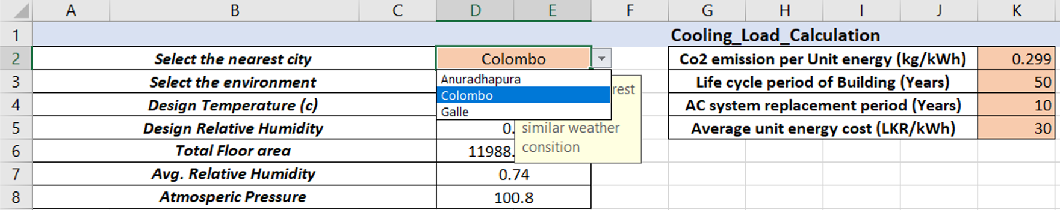

Figure 5: City selection of the automated tool

#### Digitalization of ASHRAE Heating and Cooling Load Calculation Manual

The required data of the ASHRAE heating and cooling load calculation manual is also stored digitally in several excel sheets to aid the energy simulation process.

Figure 6 shows the main interface of cooling load calculation, which is also used to get the user inputs before analysis. This main interface is supported by several support sheets, which store the CLTD, Latitude month correction values and environmental data.

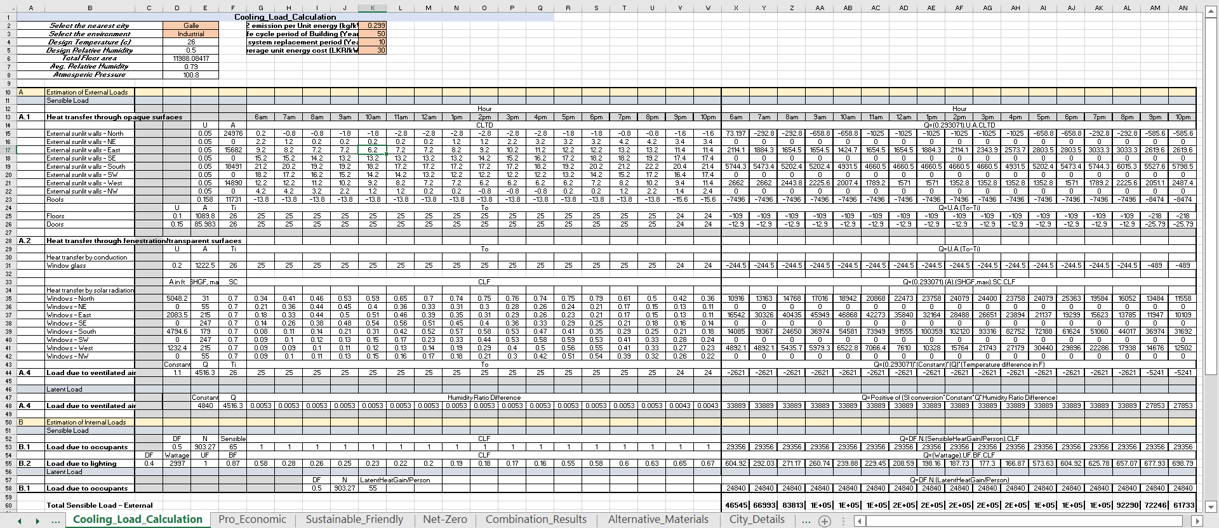

Figure 6: The main interface of the cooling load calculation menu

### BIM Model Data Extraction

2 software are used for the extraction of building data. “Revit” is used for the BIM model creation and “Dynamo” is used for the data extraction process. Only the building geometric data and details of building elements are extracted from the BIM model.

The developed Dynamo code generates various schedules and exports to a selected Excel sheet. Internal walls and internal doors are automatically removed while running the code. The following details are extracted from the BIM model.

Table 22: BIM model extraction criteria

|  |  |
| --- | --- |
| Schedule Name | Extracted criteria |
| Door Schedule | Count of doors, Width of each door, Height of each door, Area of each door |
| Wall Schedule | Area of each wall, Wall facing the direction of each wall |
| Level Schedule | Level name, Elevation of each level |
| Floor Schedule | Area of each floor |
| Window Schedule | Width of each window, Height of each window, Area of each window, Window facing direction of each window |

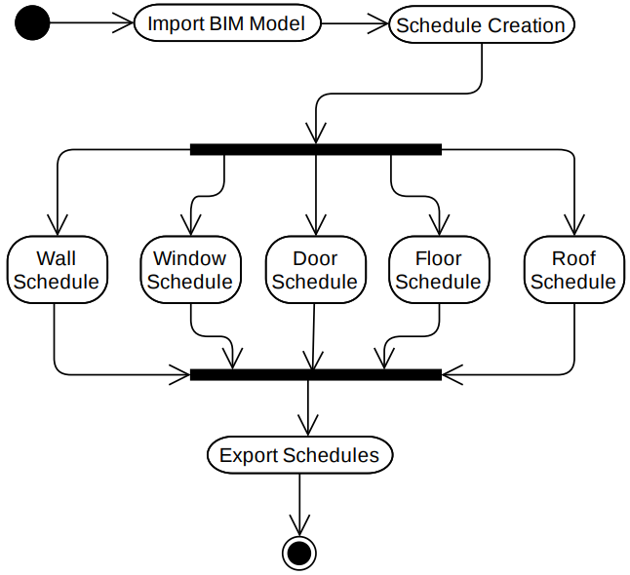A simple overview of the data extraction Dynamo code is shown in Figure 7.

Figure 7: Dynamo data extraction process

### Data Cleaning and Transformation

The exported data is then cleaned and transformed to use as the inputs for the calculations. The “Excel” software and “VBA” is used for this process and the remaining process. The data type conversion, calculating summation, calculating averages, data filtering and direction calculation process is done in this step, before the analysis process.

### Energy Simulation

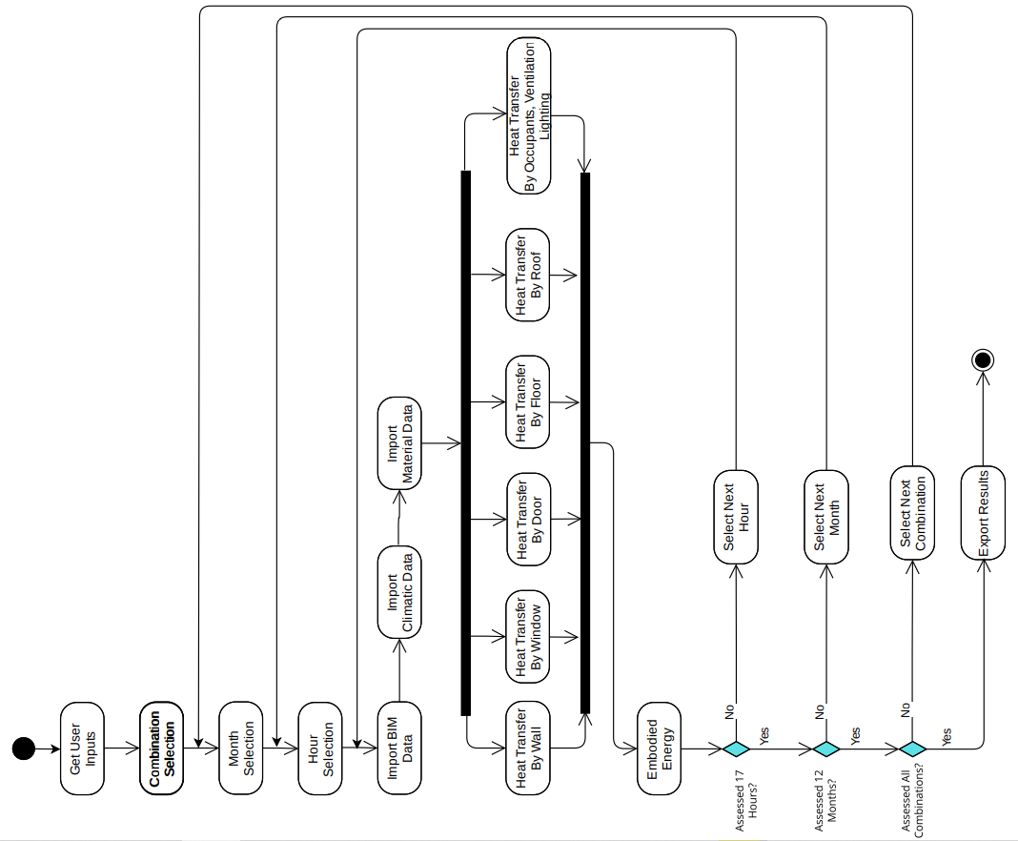

Figure 8: VBA energy simulation process

After the data transformation process, the energy simulation process is started. Calculations mentioned in the previous chapter are used for the simulation. The energy simulation is done for every combination of material/assembly. The same analysis process is done hour by hour for 17 hours (the A/C system is used 17 hours per day). After 17 iterations, the cooling load for a day can be calculated. Cooling load requirement changes throughout the year due to climatic changes. Therefore, the same calculation process is done month by month for 12 months. The number of iterations mainly depends on the number of alternative materials. 3.19 million iterations are calculated when 5 alternative materials are selected for 6 building elements ($5^{6}×17×12=3187500$). A simple overview of the energy analysis VBA code is shown in Figure 8.

### Cost Calculation

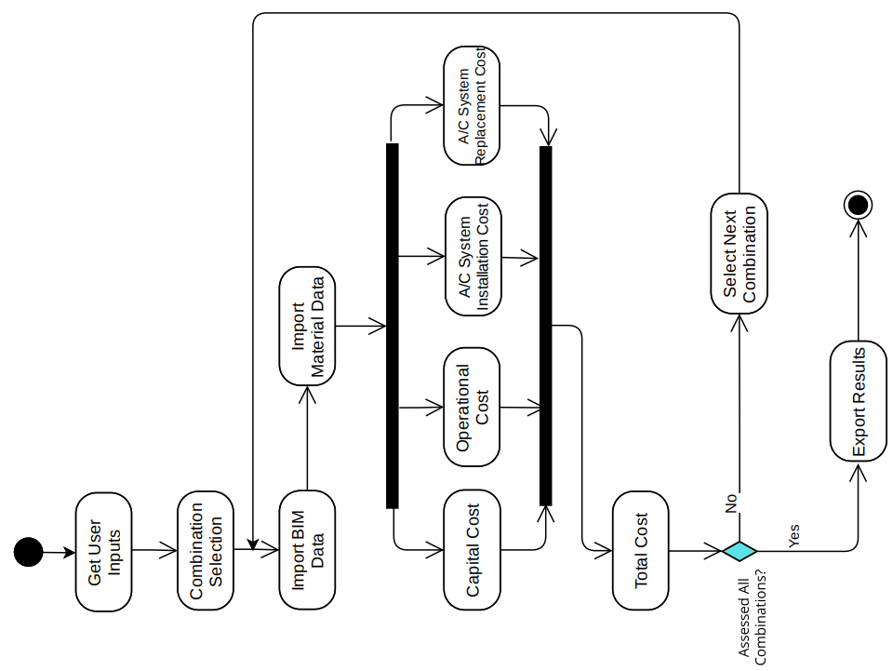

Figure 9: VBA cost calculation process

The cost is calculated simultaneously with the energy simulation. The previously mentioned cost calculation equations are used in the cost calculation process, and a simple overview of the cost calculation VBA code is shown in Figure 9.

### Carbon Footprint Calculation

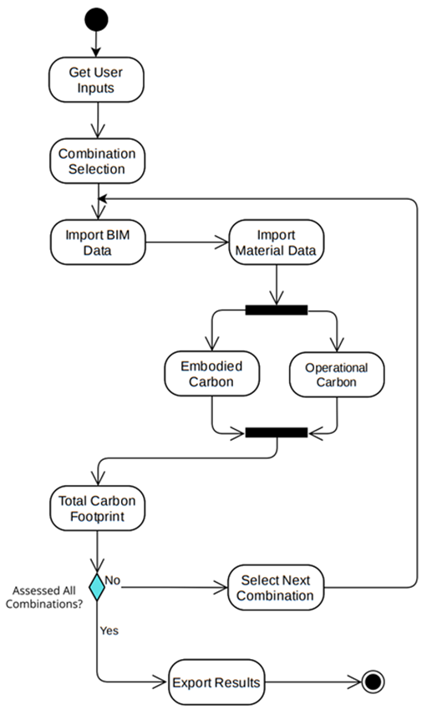

Figure 10: VBA carbon footprint simulation

The carbon footprint is calculated simultaneously with the energy simulation. The previously mentioned carbon footprint calculation equations are used in the calculation process and a simple overview of the carbon footprint calculation VBA code is shown in Figure 10.

### Orientation Analysis

The orientation analysis is done after the selection of the optimum material/assembly combination. Then the optimum materials/assembly are assigned for the 3 scenarios independently. After that, the orientation analysis was also done separately for the 3 scenarios.

A simple overview of the orientation analysis VBA code is shown in the figure below.

### Back-End Coding Using Excel VBA

Figure 11: VBA orientation analysis process

“Visual Basic for Application” (VBA) is used for calculation and analysis automation. The equations mentioned in the previous chapter are connected in the correct order using VBA coding. The decision-making process is also automated using the VBA scripting.

The developed VBA code has 5,524 lines and includes characters of more than 200,000. Some parts of the code are described in previous steps by activity diagrams. With the use of Dynamo code and Excel VBA code, the whole process is automated up to the dashboard creation.

### Dashboard Creation

After all the calculation and simulation process, a dashboard is generated to visualize the results for the user. The dashboard includes the following charts and data.

* Chart of total energy (MJ) variation with different material combinations
* Chart of total cost (LKR Million) variation with different material combinations
* Chart of total CO2 (Metric Ton) variation with different material combinations
* Optimum material combination – (Pro-Economic Scenario)
  + Wall, Window, Door, Floor, Roof, A/C System
  + Chart of performance score (TOPSIS) variation with different material combinations
* Optimum material combination – (Sustainable Friendly Scenario)
  + Wall, Window, Door, Floor, Roof, A/C System
  + Chart of performance score (TOPSIS) variation with different material combinations
* Optimum material combination – (Net-Zero Scenario)
  + Wall, Window, Door, Floor, Roof, A/C System
  + Chart of performance score (TOPSIS) variation with different material combinations
* Optimum orientation analysis – (Pro-Economic Scenario)
  + Optimum orientation angle (Degrees - Clockwise)
  + Operational energy reduction (Percentage)
  + Chart of Operational energy (kWh/year) variation
* Optimum orientation analysis – (Sustainable Friendly Scenario)
  + Optimum orientation angle (Degrees - Clockwise)
  + Operational energy reduction (Percentage)
  + Chart of Operational energy (kWh/year) variation
* Optimum orientation analysis – (Net-Zero Scenario)
  + Optimum orientation angle (Degrees - Clockwise)
  + Operational energy reduction (Percentage)
  + Chart of Operational energy (kWh/year) variation

## Case Study

### Case Study Selection

A case study is selected and obtained the results for the validation. The main user input of the study is the BIM model, which includes the geometric data and the building elements’ data. The following criteria are checked for the selection of the case study BIM model.

* Multi-family multi-story residential building
* Completed BIM model, done by Revit
* No availability of courtyards or complex geometric shapes
* Enclosed building, without a car parking
* Residential building with a flat roof

The following Revit BIM model is selected as the case study, which fulfils the above criteria.

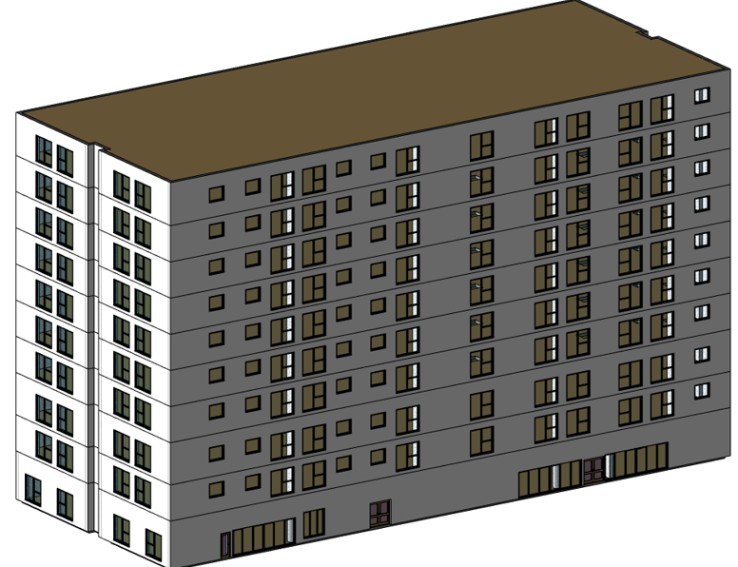

Figure 12: Revit case study BIM model

Details of the BIM model

* Floors of the building - 10
* Residential units - 126
* Total floor area - 11,076.6 m2

Revit BIM model is specified, as the developed Dynamo code only works with the Revit models. Buildings with courtyards or complex geometric shapes are avoided as the sun exposure behaviour in the courtyard is different from the external walls. Buildings with car parks are avoided, as an assumption is made that the whole building is air-conditioned. A flat roof system is also specified, as the energy analysis is done for flat roof systems.

### Results

The case study is analyzed for all the calculations mentioned above, using the automated tool. For the analysis process, the following details are used.

Table 23: Alternative wall assembly details

|  |  |  |  |  |  |  |
| --- | --- | --- | --- | --- | --- | --- |
| Alternative Wall Assembly | U Value (Btu/hr.ft2.F) | Group (ASHRAE) | Thickness (m) | Embodied Energy (MJ/m²) | Embodied Carbon (kg/m²) | Rate per sq.m (LKR) |
| 1 | 0.05 | A | 0.1 | 5 | 0.4 | 100 |
| 2 | 0.08 | B | 0.15 | 4 | 0.5 | 200 |
| 3 | 0.1 | D | 0.2 | 3 | 0.1 | 125 |
| 4 | 0.12 | F | 0.35 | 2 | 0.3 | 150 |
| 5 | 0.1428 | A | 0.15 | 1.5 | 0.2 | 160 |

Table 24: Alternative window assembly details

|  |  |  |  |  |  |
| --- | --- | --- | --- | --- | --- |
| Alternative Window Assembly | Shading Coefficient | U Value (W/m²K) | Embodied Energy (MJ/m²) | Embodied Carbon (kg/m²) | Rate per sq.m (LKR) |
| 1 | 0.7 | 0.2 | 4.5 | 4 | 1000 |
| 2 | 0.9 | 0.4 | 3.5 | 3 | 800 |
| 3 | 0.78 | 2.9214 | 3 | 1 | 500 |

Table 25: Alternative Door assembly details

|  |  |  |  |  |
| --- | --- | --- | --- | --- |
| Alternative Door Assembly | U Value (W/m²K) | Embodied Energy (MJ/m²) | Embodied Carbon (kg/m²) | Rate per sq.m (LKR) |
| 1 | 0.1 | 2 | 1.5 | 250 |
| 2 | 3.7021 | 2 | 1 | 500 |

Table 26: Alternative floor assembly details

|  |  |  |  |  |
| --- | --- | --- | --- | --- |
| Alternative Floor Assembly | U Value (W/m²K) | Embodied Energy (MJ/m²) | Embodied Carbon (kg/m²) | Rate per sq.m (LKR) |
| 1 | 0.1 | 2 | 1.4 | 350 |
| 2 | 2.9582 | 3 | 2 | 456 |

Table 27: Alternative roof assembly details

|  |  |  |  |  |
| --- | --- | --- | --- | --- |
| Alternative Roof Assembly | U Value (Btu/hr.ft2.F) | Embodied Energy (MJ/m²) | Embodied Carbon (kg/m²) | Rate per sq.m (LKR) |
| 1 | 0.213 | 3 | 2 | 150 |
| 2 | 0.206 | 3.75 | 1.75 | 175 |
| 3 | 0.2245 | 5 | 2 | 140 |

Table 28: Alternative A/C system details

|  |  |  |
| --- | --- | --- |
| AC System Name | Capacity (kW) | Cost (LKR) |
| Wall mounted - Inverter (24000BTU) | 7.034 | 372800 |
| Ceiling Mounted - Inverter (48000BTU) | 14.067 | 780000 |
| Floor mounted - Inverter (48000BTU) | 14.067 | 749240 |

The following user inputs (highlighted cells) are entered in the main interface

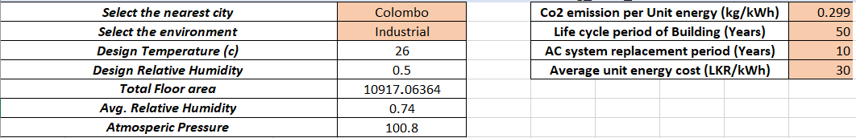

Figure 13: User inputs for the automated tool

User inputs in Figure 13 are used for the analysis. A total of 540 combinations are generated from the tool (5*3*2*2*3*3=540). Out of the 540 combinations, the results of a specific combination are shown in Table 29.

Table 29: Selected sample material combination

|  |  |
| --- | --- |
| Wall material no. | 5 |
| Window assembly no. | 3 |
| Door material no. | 2 |
| Floor assembly no. | 2 |
| Roof assembly no. | 3 |
| A/C system no. | 3 |

Table 30: Generated results for material combination in Table 29

|  |  |
| --- | --- |
| Maximum Load kWh/hr | 460.1984263 |
| No. AC Systems | 33 |
| Cooling Load (kWh/year) | 1366100.598 |
| Embodied Energy (MJ) | 47359.63573 |
| LC Operational Energy (MJ) | 245898107.6 |
| Capital Cost (LKR) | 6332337.659 |
| Operational Cost (LKR) | 2049150896 |
| System Cost (LKR) | 123624600 |
| Embodied Carbon (Metric T) | 25.9845251 |
| Operational Carbon (Metric T) | 20423.20393 |
| Total Energy (MJ) | 245945467.2 |
| Total Cost (LKR Million) | 2167.869234 |
| Total Carbon (Metric T) | 20449.18846 |

The same type of report is generated for all the 540 combinations. A summary of those results is shown as a chart. The charts in Figure 14, Figure 15 and Figure 16 are generated by the automated tool, which compares all the combinations (The chart is generated after sorting the combinations according to the total energy, cost and carbon).

Figure 14: Total energy variation for 540 combinations (After sorting)

Figure 15: Total cost variation for 540 combinations (After sorting)

Figure 16: Total carbon footprint variation for 540 combinations (After sorting)

Then, the optimum material combination is determined using AHP and TOPSIS.

* Results of pro-economic scenario

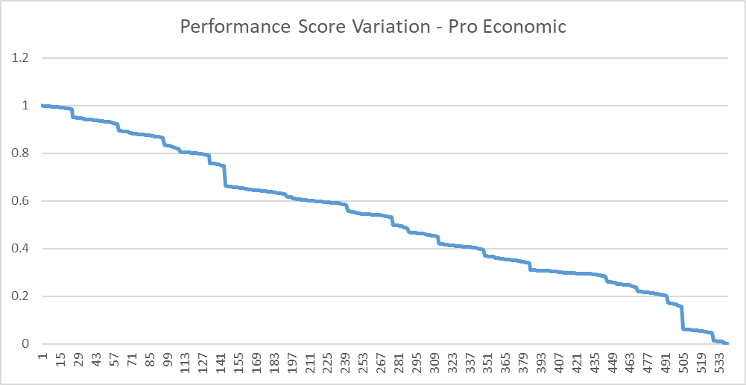

Figure 17: Performance score (TOPSIS) variation – (pro-economic scenario)



Figure 18: Optimum assembly combination (pro-economic scenario)

* 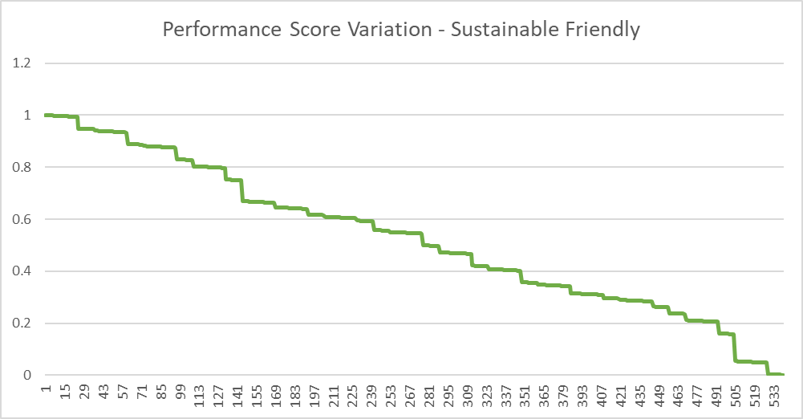Results of sustainable friendly scenario

Figure 19: Performance score (TOPSIS) variation – (sustainable friendly scenario)



Figure 20: Optimum assembly combination (sustainable friendly scenario)

* 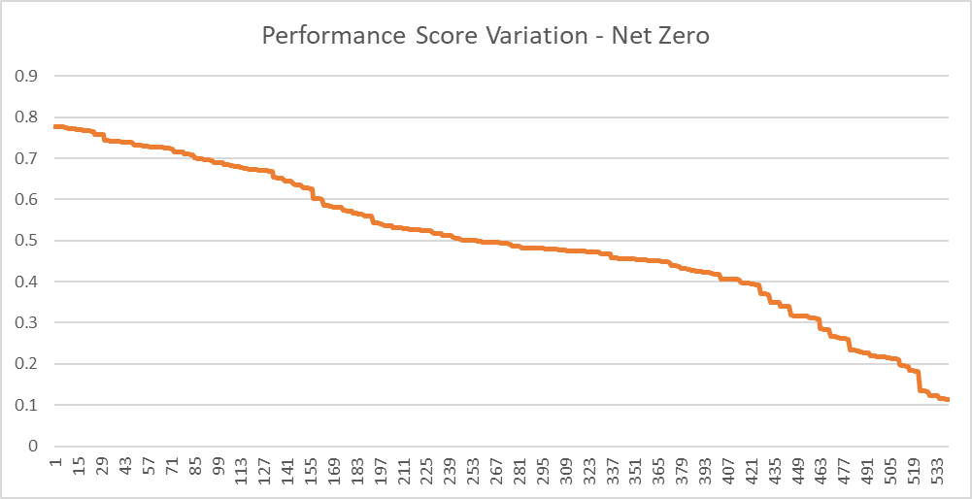Results of net-zero scenario

Figure 21: Performance score (TOPSIS) variation – (net-zero scenario)



Figure 22: Optimum assembly combination (net-zero scenario)

After selecting the optimum material combination for each scenario, those materials are assigned to the building model. After that, orientation analysis is done and the results are generated as in Figure23, Figure24 and Figure 25.

**Pro-economic scenario**

Figure 23: Operational energy variation with clockwise rotation (pro-economic)

Operational energy reduction (percentage) - 0.605350046 %

(The percentage is low, as the building is already oriented in an optimal direction)

**Sustainable friendly scenario**

Figure 24: Operational energy variation with clockwise rotation (sustainable friendly)

Operational energy reduction (percentage) - 0.605350046 %

(The percentage is low, as the building is already oriented in an optimal direction)

**Net-zero scenario**

Figure 25: Operational energy variation with clockwise rotation (net-zero)

Operational energy reduction (Percentage) - 0.624214926 %

(The percentage is low, as the building is already oriented in an optimal direction)

### Validation

Validation of the above results is done for each analysis. One combination out of 540 combinations is selected and validation is done for the following calculation.

* + Embodied energy calculation
  + Operational energy calculation
  + Capital cost calculation
  + Operational cost calculation
  + AC system cost calculation
  + Embodied carbon calculation
  + Operational carbon calculation

Considering all the combinations, the following calculations are validated.

* + Analytic Hierarchy Process (AHP)
  + Technique for Order of Preference by Similarity to Ideal Solution (TOPSIS)
  + Orientation analysis

**Embodied energy calculation**

Embodied energy calculation is validated manually by calculating embodied energy of 5 elements separately.

The material combination in Table 31 is used for validation purposes. (Same combination used for the results generation)

Table 31: Selected sample material combination (Validation)

|  |  |
| --- | --- |
| Element Type | Alternative name (No.) |
| Wall material no. | 5 |
| Window assembly no. | 3 |
| Door material no. | 2 |
| Floor assembly no. | 2 |
| Roof assembly no. | 3 |
| A/C system no. | 3 |

The material properties of these elements are mentioned in Table 23, Table 24, Table 25, Table 26, Table 27 and Table 28.

Revit schedules are created for each element and total areas are calculated. The total area, user inputs for embodied energy and the manual calculation for total energy are as follows.

Table 32: Manual embodied energy calculation

|  |  |  |  |
| --- | --- | --- | --- |
| Element type | Total area (m2) | Embodied energy (MJ/m²) | Total embodied energy (MJ) |
| Wall | 3630.42 | 1.5 | 5445.63 |
| Window | 1222.4808 | 3 | 3667.4424 |
| Door | 18.4203 | 2 | 36.8406 |
| Floor | 10917.06364 | 3 | 32751.19092 |
| Roof | 1091.706364 | 5 | 5458.53182 |
| Total | | | **47359.63574** |

Value calculated manually = 47359.63574 MJ

The value generated from the automated tool = 47359.63573 MJ

**Operational energy calculation**

The operational energy calculation process is validated by analyzing the BIM model through Revit-heating and cooling loads menu. BIM model is assigned with the above-mentioned material combination and the Revit generated report is in Figure 26.

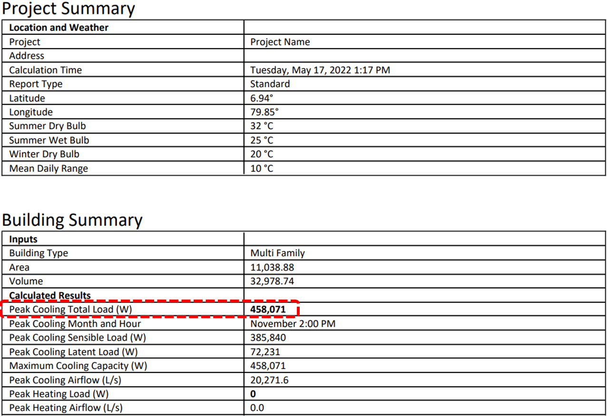Peak cooling load value generated by automated tool = 460.1984 kW

Figure 26: Operational energy report (Revit)

Peak cooling load value generated by Revit = 458.0710 kW

Deviation of operational energy = $\frac{(460.1984-458.071)}{458.0710}×100\%$ = 0.46%

**Capital cost calculation**

Revit schedules are created for each element and total areas are calculated. The total area, user inputs for material rate and the manual calculation for the total cost are as follows.

Table 33: Manual capital cost calculation

|  |  |  |  |
| --- | --- | --- | --- |
| Element type | Total area (m2) | Rate of element (LKR) | Total cost (LKR) |
| Wall | 3630.42 | 160 | 580867.2 |
| Window | 1222.4808 | 500 | 611240.4 |
| Door | 18.4203 | 500 | 9210.15 |
| Floor | 10917.06364 | 456 | 4978181.02 |
| Roof | 1091.706364 | 140 | 152838.891 |
| Total | | | **6332337.661** |

Value calculated manually = 6332337.661 LKR

The value generated from the automated tool = 6332337.659 LKR

**Operational Cost (A/C system)**

Operational cost is validated by multiplying the operational energy and the average unit energy cost.

Annual energy consumption = 1366100.598 kWh

The life cycle of building = 50 years

Average unit energy cost = 30 LKR/kWh

Operational cost = 1366100.598 * 50 * 30 = 2,049,150,897 LKR

Manually calculated operational cost = 2,049,150,897 LKR

Cost generated by automated tool = 2,049,150,896 LKR

**A/C system cost**

A/C system cost is validated by manual calculation.

A/C system price (1 unit) = 749240 LKR

The life cycle of building = 50 years

The life cycle of an A/C unit = 10 years

The capacity of the A/C unit = 14.067 kW

Peak cooling load = 458.0710 kW

Number of A/C units for building = $\frac{Peak cooling load}{capacity of AC unit}=\frac{458.0710}{14.067}$ => 33

Number of replacements = $\frac{Life cycle of building}{Life cycle of AC unit}=\frac{50}{10}$ => 5

A/C system cost = 749240 * 33 * 5 = 123,624,600 LKR

Manually calculated A/C system cost = 123,624,600 LKR

Cost generated from automated tool = 123,624,600 LKR

Accuracy of system cost = $\frac{123624600}{123624600}×100\%$ = 100%

**Embodied carbon**

Revit schedules are created for each element and total areas are calculated. The total area, user inputs for embodied carbon and the manual calculation for total embodied carbon are as follows.

Table 34: Manual embodied carbon calculation

|  |  |  |  |
| --- | --- | --- | --- |
| Element type | Total area (m2) | Embodied carbon (kg/m²) | Total embodied carbon (kg) |
| Wall | 3630.42 | 0.2 | 726.084 |
| Window | 1222.4808 | 1 | 1222.4808 |
| Door | 18.4203 | 1 | 18.4203 |
| Floor | 10917.06364 | 2 | 21834.12728 |
| Roof | 1091.706364 | 2 | 2183.412728 |
| Total | | | **25984.52511** |

Value calculated manually = 25984.52511 kg

The value generated from the automated tool = 25984.5251 kg

**Operational Carbon (A/C system)**

Operational carbon is validated by multiplying the operational energy and the CO2 emission per unit of energy.

Annual energy consumption = 1366100.598 kWh

The life cycle of building = 50 years

CO2 emission per unit energy = 0.299 kg/kWh

Operational carbon emission = 1366100.598 * 50 * 0.299 = 20,423,203.94 kg

Manually calculated operational carbon emission = 20,423,203.94 kg

Carbon emission generated by automated tool = 20,423,203,93 kg

**Analytic Hierarchy Process (AHP)**

Weightages derived from the automated tool are validated by a manual calculation process for the pro-economic scenario.

**Step 1** – Pair-wise comparison

Table 35: AHP pair-wise comparison

|  |  |  |  |
| --- | --- | --- | --- |
| Attributes | Energy | Cost | CO2 |
| Energy | 1 | 0.2 | 3 |
| Cost | 5 | 1 | 7 |
| CO2 | 0.333 | 0.1429 | 1 |

**Steps 2,3,4 and 5** – A1, A2, A3, A4, matrix generation

Table 36: AHP-A1, A2, A3, A4 matrices generation

|  |  |  |  |
| --- | --- | --- | --- |
| A1 Matrix | A2 Matrix | A3 Matrix | A4 Matrix |
| 0.843432665 | 0.188397658 | 0.577360931 | 3.06458656 |
| 3.27106631 | 0.730658483 | 2.239253784 | 3.064706474 |
| 0.362375494 | 0.080943859 | 0.248091376 | 3.064980842 |
| 4.47687447 | 1 |  | 3.064757958 |
| (Sum) | (Sum) |  | (Average) |

Consistency index = $\frac{λ_{max}-n}{n-1}=\frac{3.064757958-3}{3-1}$ = 0.032378979

Consistency ratio = Consistency index/Random index = 0.032378979/0.52 = 0.0622 (< 0.1)

Therefore, the A2 matrix can be taken as weightages

Table 37: Weightages for pro-economic scenario

|  |  |  |
| --- | --- | --- |
| Attribute | Manually derived weightages | Automated tool derived weightages |
| Total Energy | 0.188397658 | 0.1884 |
| Total Cost | 0.730658483 | 0.7307 |
| CO2 emission | 0.080943859 | 0.0809 |

**Technique for Order of Preference by Similarity to Ideal Solution (TOPSIS)**

The ranking order is validated by a manual calculation process for the pro-economic scenario. Excel is used for computing each step, as the matrix is 3 x 540.

**Step 1 – Generating evaluation matrix**

Evaluation matrix – Pro-economic scenario.

* Column 1 - Total cost
* Column 2 – Total energy
* Column 3 – Total carbon emission
* 540 rows – 540 combinations

$${X=\left[\begin{matrix}1867.075027 & ⋯ & 17722.20686 \\ ⋮ & ⋱ & ⋮ \\ 2029.792591 & ⋯ & 19185.03596\end{matrix}\right]}_{540×3}$$

**Step 2 – Matrix normalization**

The normalized matrix (R) is generated.

$r_{i,j}=\frac{x_{i,j}}{\sqrt{\sum_{k=1}^{m}{x_{k,j}^{2}}}}$, i= 1, 2, …, m and j = 1, 2,…, n

$${R=\left[\begin{matrix}0.038768005 & ⋯ & 0.038861089 \\ ⋮ & ⋱ & ⋮ \\ 0.042146678 & ⋯ & 0.042068767\end{matrix}\right]}_{540×3}$$

**Step 3 – Weighted normalized matrix**

The weighted normalized matrix (T) is generated.

$${T=\left[\begin{matrix}0.028327781 & ⋯ & 0.003143862 \\ ⋮ & ⋱ & ⋮ \\ 0.030796577 & ⋯ & 0.003403363\end{matrix}\right]}_{540×3}$$

$t_{i,j}=r_{i,j}×w_{j}$, i= 1, 2, …, m and j = 1, 2…, n

$w_{1}=0.7307, w_{2}=0.1884,w_{3}=0.0809$

$w_{j}$ is the weightage, derived by the AHP method.

**Step 4 – Determining the best and worst solution for each attribute**

Best solution = $t_{best,j} | j=1,2,…, n$

Worst solution = $t_{worst,j} | j=1,2,…, n$

$$t_{best,1}=0.027920707,t_{best,2}=0.007209173,t_{best,3}=0.003095911$$

$$t_{worst,1}=0.03521508,t_{worst,2}=0.009074966,t_{worst,3}=0.003897041$$

**Step 5 – Calculating Euclidean distance from best and worst**

The Euclidean distance from the worst condition is , and the Euclidean distance from the best condition is .

i= 1, 2, …, m

i= 1, 2, …, m

**Step 6 – Calculation of similarity to the worst condition**

The similarity to the worst condition ($s_{i,w}$) is calculated using the following equation,

$s_{i,w}=\frac{d_{i,worst}}{d_{i,worst}+d_{i,best}} , 0≤s_{i,w}≤1$, i= 1, 2, …, m

$$s_{w}=0.943884576,0.936249469,0.943080225,………,0.606494675$$

**Step 7 – Ranking the combinations**

The performance score of the first 5 combinations calculated from the manual calculation and automated tool is mentioned in Table 38.

Table 38: Comparison of TOPSIS manual and automated tool calculation

|  |  |  |
| --- | --- | --- |
| Combination number | Performance score (Sw- Manual calculation) | Performance score (Sw- Automated tool) |
| 1 | 0.943884576 | 0.943884576 |
| 2 | 0.936249469 | 0.936249469 |
| 3 | 0.943080225 | 0.943080225 |
| 4 | 0.940568622 | 0.940568622 |
| 5 | 0.932934572 | 0.932934572 |

All performance scores of 540 combinations are similar between the manual calculation and the automated tool. Therefore, the ranking sequence is also similar to each other.

**Orientation analysis**

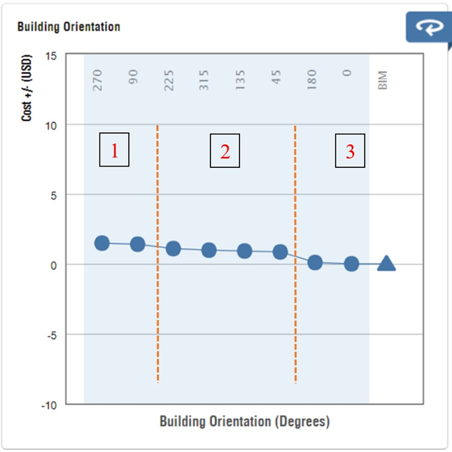The optimum orientation calculation process is validated by analyzing the BIM model through Autodesk cloud-based “Insight”. BIM model is assigned with the above-mentioned material combination and the following output is generated from “Insight”.

Figure 27: Autodesk "Insight" orientation analysis

A chart as in Figure 27 is developed with cost per area per year (USD/m2/year) vs the building's clockwise orientation (degrees). The results can be categorized into 3 categories according to the cost per area per year value. Area 1 represents the least energy-efficient orientations. Area 2 represents moderately energy efficient orientations and area 3 represents the highest energy efficient orientations.

Comparison of orientation analysis between “Insight” result and the automated tool output.

Table 39: Comparison of manual and "Insight" orientation analysis

|  |  |  |
| --- | --- | --- |
| Efficiency level | Insight results (Orientation – degrees) | Automated tool results (Orientation – degrees) |
| Highest energy efficient | 0 0, 180 0 | 0 0, 180 0 |
| Medium energy efficient | 45 0, 135 0, 225 0, 315 0 | 45 0, 135 0, 225 0, 315 0 |
| Least energy efficient | 90 0, 270 0 | 90 0, 270 0 |

**Summary of validation**

Table 40: Summary of validation

|  |  |
| --- | --- |
| The calculation process of the automated tool | Accuracy percentage |
| Embodied energy calculation | 100% |
| Operational energy calculation | 99.54% |
| Capital cost | 100% |
| Operational cost | 100% |
| A/C system cost | 100% |
| Embodied carbon | 100% |
| Operational carbon | 100% |
| AHP | 100% |
| TOPSIS | 100% |
| Orientation analysis | 100% |

# DISCUSSION

The results and the validation confirm that the developed automated tool has used accurate calculation processes and calculation sequences. Embodied energy calculation, capital cost calculation, operational cost calculation, A/C system cost calculation, embodied carbon calculation, operational carbon calculation, AHP method, TOPSIS method and the orientation analysis have a 100% accuracy. Operational energy calculation has an accuracy of more than 99.5%.

The slight variation of the results of operational energy could happen due to the following 3 major reasons.

* The difference between climatic data inputs between the two methods

The Revit software uses dry bulb temperature, wet bulb temperature and mean daily range for the operational energy calculation. The developed tool uses hour-by-hour climatic temperature inputs throughout the day for the calculation.

* Assumption of not considering the interior walls and interior doors.

The developed tool analyzes the building for operational energy only using the details of the building envelope and floors. There could be some effect on the building energy consumption by the interior walls and the interior doors.

* Different calculation methods between Revit and automated tool

The developed tool uses the ASHRAE “Heating and cooling load calculation manual – CLTD/CLF” method for the operational energy calculation. Revit uses a different version of the ASHRAE method. Therefore, the input parameters and equations used for the calculation may differ between the two methods.

The above 3 reasons caused the variation in the operational energy calculation and the peak cooling load calculation. The A/C system cost also differs, as the peak cooling load is used for the calculation.

Other assumptions made during the analysis (Not considering the internal building components and assuming earth temperature same as the air outside air temperature) are proved to be acceptable as the operational energy result has an accuracy of more than 99.5%.

As per the results, around 66% of heat is transferred by the windows. Around 18% by the people. (Percentages may vary with different material combinations and different window sizes). Therefore, the type of windows used in the building highly affects the air conditioning energy consumption.

**Future works on this research**

The accuracy of the tool can be further increased by analyzing zone by zone of the BIM model separately while considering the impacts of surrounding buildings and objects. The usability can be further improved by extending the capability of this tool to countries other than Sri Lanka.

The accuracy can be further improved by implementing the latest ASHRAE manual into the tool or by joining the tool with another standalone energy analyzing software.

The same research methodology can be implemented for the buildings other than apartments with some modifications to the visual basic script.

Another improvement for this study would be implementing the cooling load calculation of the basement floors.

# Conclusions and Recommendations

This research developed an automated software tool, which can select the optimum building material and system combination for a selected building as per the requirements of the client. The automated tool is developed by using Dynamo, Excel and VBA coding which can analyze the Revit BIM models. This tool is capable of analysing embodied carbon, operational carbon, embodied energy, operational energy, capital cost, operational cost, A/C system cost and orientation analysis of a multi-story multi-family residential building. After the analysis, the MCDM approach is used to obtain the optimum material and system combination.

A 10-story apartment building BIM model and sample alternative material data are used for the calculation in this study. The optimum material combination is selected for 3 different scenarios independently (pro-economic scenario, sustainable friendly scenario and net-zero scenario).

According to the optimum material/system selection of automated tool, operational cooling load demand and operational cost can be reduced by 20.6%. The embodied energy of the apartment building can be reduced by 41.7%, The capital cost can be reduced by 18.7% and the A/C system cost can be reduced by 24.2%.

According to the optimum orientation analysis of the automated tool, operational cooling load demand and operational cost can be further reduced by 19.9%. Therefore, the A/C system cost also can be further reduced by 6.3%.

Therefore, this automated tool can be used in the design phase of multi-story multi-family residential buildings in Sri Lanka to optimize the cost, energy consumption and carbon footprint of the project. It is a one-step of long-term solution to the rapidly increasing energy crisis in Sri Lanka.

# REFERENCES

Abanda, F. H., & Byers, L. (2016). An investigation of the impact of building orientation on energy consumption in a domestic building using emerging BIM (Building Information Modelling). *Energy*, *97*, 517–527. https://doi.org/10.1016/J.ENERGY.2015.12.135

Abd Rashid, A. F., & Yusoff, S. (2015). A review of life cycle assessment method for building industry. In *Renewable and Sustainable Energy Reviews* (Vol. 45, pp. 244–248). Pergamon. https://doi.org/10.1016/j.rser.2015.01.043

Adalberth, K. (1997). Energy use during the life cycle of single-unit dwellings: Examples. *Building and Environment*, *32*(4), 321–329. https://doi.org/10.1016/S0360-1323(96)00069-8

Aktacir, M. A., Büyükalaca, O., & Yilmaz, T. (2006). Life-cycle cost analysis for constant-air-volume and variable-air-volume air-conditioning systems. *Applied Energy*, *83*(6), 606–627. https://doi.org/10.1016/J.APENERGY.2005.06.002

Alshamrani, O. S. (2012). Evaluation of School Buildings Using Sustainability Measures and Life-Cycle Costing Technique. In *Thesis* (Issue July). http://spectrum.library.concordia.ca/974483/?utm_source=rss&utm_medium=rss&utm_campaign=evaluation-of-school-buildings-using-sustainability-measures-and-life-cycle-costing-technique

Amasyali, K., & El-Gohary, N. M. (2018). A review of data-driven building energy consumption prediction studies. *Renewable and Sustainable Energy Reviews*, *81*, 1192–1205. https://doi.org/10.1016/J.RSER.2017.04.095

Azhar, S. (2011). Building information modeling (BIM): Trends, benefits, risks, and challenges for the AEC industry. *Leadership and Management in Engineering*, *11*(3), 241–252. https://doi.org/10.1061/(ASCE)LM.1943-5630.0000127

Benoît-Norris, C., Vickery-Niederman, G., Valdivia, S., Franze, J., Traverso, M., Ciroth, A., & Mazijn, B. (2011). Introducing the UNEP/SETAC methodological sheets for subcategories of social LCA. *The International Journal of Life Cycle Assessment 2011 16:7*, *16*(7), 682–690. https://doi.org/10.1007/S11367-011-0301-Y

Bribián, I. Z., Capilla, A. V., & Usón, A. A. (2011). Life cycle assessment of building materials : Comparative analysis of energy and environmental impacts and evaluation of the eco-ef fi ciency improvement potential. *Building and Environment*, *46*(5), 1133–1140. https://doi.org/10.1016/j.buildenv.2010.12.002

Castro-Lacouture, D., Sefair, J. A., Flórez, L., & Medaglia, A. L. (2009). Optimization model for the selection of materials using a LEED-based green building rating system in Colombia. *Building and Environment*, *44*(6), 1162–1170. https://doi.org/10.1016/J.BUILDENV.2008.08.009

Chau, C. K., Leung, T. M., & Ng, W. Y. (2015). A review on Life Cycle Assessment, Life Cycle Energy Assessment and Life Cycle Carbon Emissions Assessment on buildings. *Applied Energy*, *143*(1), 395–413. https://doi.org/10.1016/J.APENERGY.2015.01.023

Chen, G. Q., Chen, H., Chen, Z. M., Zhang, B., Shao, L., Guo, S., Zhou, S. Y., & Jiang, M. M. (2011). Low-carbon building assessment and multi-scale input–output analysis. *Communications in Nonlinear Science and Numerical Simulation*, *16*(1), 583–595. https://doi.org/10.1016/J.CNSNS.2010.02.026

Egan, W., & Iacovelli, J. (1996). Projected Life Cycle Costs of an Exterior Insulation and Finish System. *ASTM Special Technical Publication*, *1269*, 189–207. https://doi.org/10.1520/STP39221S

Fay, R., Treloar, G., & Iyer-Raniga, U. (2010). Life-cycle energy analysis of buildings: a case study. *Http://Dx.Doi.Org/10.1080/096132100369073*, *28*(1), 31–41. https://doi.org/10.1080/096132100369073

Florez, L., & Castro-Lacouture, D. (2013). Optimization model for sustainable materials selection using objective and subjective factors. *Materials & Design*, *46*, 310–321. https://doi.org/10.1016/J.MATDES.2012.10.013

Gass, S. I., & Assad, A. A. (2005). Model world: Tales from the time line - The definition of OR and the origins of Monte Carlo simulation. *Interfaces*, *35*(5), 429–435. https://doi.org/10.1287/INTE.1050.0160

Ghrici, M., Kenai, S., & Said-Mansour, M. (2007). Mechanical properties and durability of mortar and concrete containing natural pozzolana and limestone blended cements. *Cement and Concrete Composites*, *29*(7), 542–549. https://doi.org/10.1016/J.CEMCONCOMP.2007.04.009

Gong, X., Nie, Z., Wang, Z., Cui, S., Gao, F., & Zuo, T. (2012). Life Cycle Energy Consumption and Carbon Dioxide Emission of Residential Building Designs in Beijing. *Journal of Industrial Ecology*, *16*(4), 576–587. https://doi.org/10.1111/J.1530-9290.2011.00415.X

Guinee, J. B., Gorree, M., Heijungs, R., Huppes, G., Kleijn, R., van Oers, L., Wegener Sleeswijk, A., Suh, S., de Haes, U., de Bruijn, H., van Duin, R., & Huijbregts, M. A. J. (2001). Handbook on Life Cycle Assessment, Operational guide to the ISO standards Volume 1, 2a, 2b and 3. *Journal of Cleaner Production*, *6*(5), 311–313. https://books.google.com/books/about/Handbook_on_Life_Cycle_Assessment.html?id=Q1VYuV5vc8UC

Hellweg, S., & Canals, L. M. i. (2014). Emerging approaches, challenges and opportunities in life cycle assessment. *Science*, *344*(6188), 1109–1113. https://doi.org/10.1126/SCIENCE.1248361

Jafari, A., Valentin, V., & Russell, M. (2014). Probabilistic Life Cycle Cost Model for Sustainable Housing Retrofit Decision-Making. *Computing in Civil and Building Engineering - Proceedings of the 2014 International Conference on Computing in Civil and Building Engineering*, 1925–1933. https://doi.org/10.1061/9780784413616.239

Jalaei, F., Jrade, A., professor, A., Nassiri, M., Zelkowicz, A., Iorio, J., & Taylor, J. E. (2015). Integrating decision support system (DSS) and building information modeling (BIM) to optimize the selection of sustainable building components. *Researchgate.Net*, *20*, 399–420. https://www.researchgate.net/profile/Farzad-Jalaei/publication/306178146_Integrating_decision_support_system_DSS_and_building_information_modeling_BIM_to_optimize_the_selection_of_sustainable_building_components/links/5ac69c4faca272abdc5cbd3a/Integrating-decision-support-system-DSS-and-building-information-modeling-BIM-to-optimize-the-selection-of-sustainable-building-components.pdf

Jayasena, H., & Weddikkara, C. (2012). *Building information modelling for Sri Lankan construction industry*.

Khosrowshahi, F., & Arayici, Y. (2012). Roadmap for implementation of BIM in the UK construction industry. *Engineering, Construction and Architectural Management*, *19*(6), 610–635. https://doi.org/10.1108/09699981211277531/FULL/XML

Kumara, E. K. A. S., Jayasena, H. S., & Ariyachandra, M. R. M. F. (2017). *Software capabilities of Sri Lankan architectural professionals for BIM adoption*. http://dl.lib.uom.lk/handle/123/17296

Liu, Z., Osmani, M., Demian, P., & Baldwin, A. N. (2011). *The potential use of BIM to aid construction waste minimalisation*. 26–28. /articles/conference_contribution/The_potential_use_of_BIM_to_aid_construction_waste_minimalisation/9427652/1

Marzouk, M., Azab, S., & Metawie, M. (2018). BIM-based approach for optimizing life cycle costs of sustainable buildings. *Journal of Cleaner Production*, *188*, 217–226. https://doi.org/10.1016/J.JCLEPRO.2018.03.280

Matsuo, Y., Yanagisawa, A., & Yamashita, Y. (2013). A global energy outlook to 2035 with strategic considerations for Asia and Middle East energy supply and demand interdependencies. *Energy Strategy Reviews*, *2*(1), 79–91. https://doi.org/10.1016/J.ESR.2013.04.002

McGraw Hill. (2014). *The Business Value of BIM for Construction in Major Global Markets: How Contractors Around the World Are Driving Innovation With Building Information Modeling*. https://www.academia.edu/27756523/The_Business_Value_of_BIM_for_Construction_in_Major_Global_Markets_How_Contractors_Around_the_World_Are_Driving_Innovation_With_Building_Information_Modeling

Moussatche, H., & Languell, J. (2001). Flooring materials – life‐cycle costing for educational facilities. *Facilities*, *19*(10), 333–343. https://doi.org/10.1108/02632770110399370

O’Reilly, A. (2017). Using BIM as a tool for cutting construction waste at source. *Http://Dx.Doi.Org/10.1080/20450249.2012.11873828*, *3*(1), 28–31. https://doi.org/10.1080/20450249.2012.11873828

Oti, A. H., & Tizani, W. (2015). BIM extension for the sustainability appraisal of conceptual steel design. *Advanced Engineering Informatics*, *29*(1), 28–46. https://doi.org/10.1016/J.AEI.2014.09.001

Paiho, S., Pulakka, S., & Knuuti, A. (2017). Life-cycle cost analyses of heat pump concepts for Finnish new nearly zero energy residential buildings. *Energy and Buildings*, *150*, 396–402. https://doi.org/10.1016/J.ENBUILD.2017.06.034

Pan, Y., Zuo, M., & Wu, G. (2010). Whole building energy simulation and energy saving potential analysis of a large public building. *Http://Dx.Doi.Org/10.1080/19401491003721301*, *4*(1), 37–47. https://doi.org/10.1080/19401491003721301

Porwal, A., & Hewage, K. N. (2012). Building Information Modeling–Based Analysis to Minimize Waste Rate of Structural Reinforcement. *Journal of Construction Engineering and Management*, *138*(8), 943–954. https://doi.org/10.1061/(ASCE)CO.1943-7862.0000508

Ramesh, T., Prakash, R., & Shukla, K. K. (2010). Life cycle energy analysis of buildings: An overview. *Energy and Buildings*, *42*(10), 1592–1600. https://doi.org/10.1016/j.enbuild.2010.05.007

Rodrigues, F., Isayeva, A., Rodrigues, H., & Pinto, A. (2020). Energy efficiency assessment of a public building resourcing a BIM model. *Innovative Infrastructure Solutions 2020 5:2*, *5*(2), 1–12. https://doi.org/10.1007/S41062-020-00291-1

Sacks, R., Koskela, L., Dave, B. A., & Owen, R. (2010). Interaction of Lean and Building Information Modeling in Construction. *Journal of Construction Engineering and Management*, *136*(9), 968–980. https://doi.org/10.1061/(ASCE)CO.1943-7862.0000203

Sartori, I., & Hestnes, A. G. (2007). Energy use in the life cycle of conventional and low-energy buildings: A review article. *Energy and Buildings*, *39*(3), 249–257. https://doi.org/10.1016/J.ENBUILD.2006.07.001

Scheuer, C., Keoleian, G. A., & Reppe, P. (2003). Life cycle energy and environmental performance of a new university building: modeling challenges and design implications. *Energy and Buildings*, *35*(10), 1049–1064. https://doi.org/10.1016/S0378-7788(03)00066-5

Schlueter, A., & Thesseling, F. (2009). Building information model based energy/exergy performance assessment in early design stages. *Automation in Construction*, *18*(2), 153–163. https://doi.org/10.1016/J.AUTCON.2008.07.003

Shahata, K., & Zayed, T. (2008). Life-Cycle Cost Based Rehabilitation Plan for Water Mains. *World Environmental and Water Resources Congress 2008: Ahupua’a - Proceedings of the World Environmental and Water Resources Congress 2008*, *316*, 1–16. https://doi.org/10.1061/40976(316)673

Simões, C. L., Costa Pinto, L. M., Simoes, R., & Bernardo, C. A. (2013). Integrating environmental and economic life cycle analysis in product development: a material selection case study. *The International Journal of Life Cycle Assessment 2013 18:9*, *18*(9), 1734–1746. https://doi.org/10.1007/S11367-013-0561-9

Smith, P. (2014). BIM Implementation – Global Strategies. *Procedia Engineering*, *85*, 482–492. https://doi.org/10.1016/J.PROENG.2014.10.575

Soust-Verdaguer, B., Llatas, C., & García-Martínez, A. (2017). Critical review of bim-based LCA method to buildings. *Energy and Buildings*, *136*, 110–120. https://doi.org/10.1016/J.ENBUILD.2016.12.009

Sri Lanka Sustainable Energy Authority. (2017). *Energy Balance 2017 Sri Lanka*.

Thapothiny, S., Gunatilake, S., & Manjula, N. H. C. (2017). *Incorporating facility managers into the design and construction phases to enhance building performance*. http://dl.lib.uom.lk/handle/123/17491

United Nations Environment Program. (2009). *Common Carbon Metric. For measuring Energy Use & reporting Greenhouse Gas Emissions from building operations*. 28. https://wedocs.unep.org/handle/20.500.11822/7922

Valipour, M. (2015). Temperature analysis of reference evapotranspiration models. *Meteorological Applications*, *22*(3), 385–394. https://doi.org/10.1002/MET.1465

Vitiello, U., Asprone, D., Di Ludovico, M., & Prota, A. (2016). Life-cycle cost optimization of the seismic retrofit of existing RC structures. *Bulletin of Earthquake Engineering 2016 15:5*, *15*(5), 2245–2271. https://doi.org/10.1007/S10518-016-0046-X

Wang, N., Chang, Y.-C., & El-Sheikh, A. A. (2010). Monte Carlo simulation approach to life cycle cost management. *Http://Dx.Doi.Org/10.1080/15732479.2010.481304*, *8*(8), 739–746. https://doi.org/10.1080/15732479.2010.481304

Wang, S. Q., Wang, W., & Zhang, X. (2008). *Calculation and analysis on energy consumption of residential buildings in severe cold region based on life cycle theory*. https://scholar.google.com/scholar?hl=en&as_sdt=0%2C5&q=Calculation+and+analysis+on+energy+consumption+of+residential+buildings+in+severe+cold+region+based+on+life+cycle+theory&btnG=

Yang, W., & Wang, S. S. (2013). A BIM-LCA framework and case study of a residential building in Tianjin. *Modeling and Computation in Engineering II - Proceedings of the 2nd SREE Conference on Modeling and Computation in Engineering, CMCE 2013*, 83–88. https://doi.org/10.1201/b14896-14

Yohanis, Y. G., & Norton, B. (2002). Life-cycle operational and embodied energy for a generic single-storey office building in the UK. *Energy*, *27*(1), 77–92. https://doi.org/10.1016/S0360-5442(01)00061-5

You, F., Hu, D., Zhang, H., Guo, Z., Zhao, Y., Wang, B., & Yuan, Y. (2011). Carbon emissions in the life cycle of urban building system in China—A case study of residential buildings. *Ecological Complexity*, *8*(2), 201–212. https://doi.org/10.1016/J.ECOCOM.2011.02.003

Zhong, P. (2005). *Study of building life-cycle energy use and relevant environmental impacts*. https://scholar.google.com/scholar?hl=en&as_sdt=0%2C5&q=Study+of+building+life-cycle+energy+use+and+relevant+environmental&btnG=